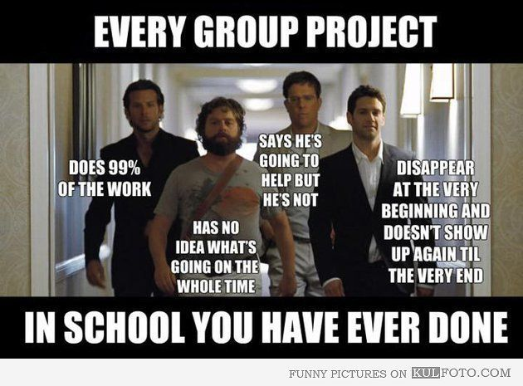

What's happening in the meme?

___________________________________________________________________

___________________________________________________________________

___________________________________________________________________

What does the meme tell us about school?

___________________________________________________________________

___________________________________________________________________

___________________________________________________________________