|  |
| --- |
| Introduction Today you'll be immersing yourself in the life of a stranger and dealing with their finances. It's all about saving money. |

|  |  |
| --- | --- |
|  | Lisa  I'm Lisa, a 25-year-old saleswoman, and I never thought much about saving. My earnings quickly disappeared on clothes, food, and travel. Now, after losing my job, I'm struggling with just $50 in my account. Rent, utilities, and daily expenses are piling up, forcing me to borrow from friends and overdraw my account, creating high-interest debt. I'm stressed and overwhelmed, unsure of how to navigate this financial crisis without a safety net. |

### 📝 Task

Summarize the person's problem.

___________________________________________________________________

___________________________________________________________________

___________________________________________________________________

___________________________________________________________________

📌The person has ended up in a rather difficult situation and needs help. Can you help them solve their problem?

# My Spending Habits

In recent years, I've developed several habits that, looking back, weren't the wisest when it came to managing my finances. One of my recurring tendencies was making impulsive purchases. I'd often find myself buying clothes or gadgets on a whim, just because they caught my eye. These seemingly small expenses added up over time, without me truly realizing the impact.

I never really had a solid budget plan. I had a general sense of how much I needed monthly for my living expenses, but I never detailed where every euro was going each month. This lack of oversight led to a gradual loss of control over my finances.

Another aspect I rarely questioned were my fixed costs. For instance, I've had a gym membership for years that I hardly ever used. It always seemed like a good idea, but in reality, I might have gone once or twice a month. These regular monthly expenses quietly accumulated over time.

I was also missing long-term financial goals. Living in the moment was my mantra, rarely thinking about the future. While I knew setting aside savings was important, I never truly acted on it. I didn't have an emergency fund to fall back on during unexpected times.

Reward purchases were another pitfall for me. After a tiring week, I'd often treat myself to something special, like an expensive dinner or a new piece of clothing. It always felt good to indulge, but in the long run, these treats only made my financial situation worse.

Finally, I held onto various subscriptions that I barely utilized. Magazine subscriptions, streaming services, and other monthly memberships continued without regular use or review. These unnecessary expenses quietly drained my budget further.

All these behaviors combined meant that I struggled to save money effectively, leading me to the challenging financial predicament I face now.

### 📝 Task

List possible misconduct by the person in dealing with money and note how they could have behaved better.

Fill in the following table:

|  |  |
| --- | --- |
| Mistakes | How could the person have done better? |
|  |  |
|  |  |
|  |  |
|  |  |
|  |  |
|  |  |
|  |  |

📝 The person wants to learn from their mistakes. Formulate 5 general tips for saving money.

___________________________________________________________________

___________________________________________________________________

___________________________________________________________________

Group work

### Group work

### 📝 Task

Imagine the person asks you for advice. Explain to them how they can avoid getting into such a difficult situation again.

___________________________________________________________________

___________________________________________________________________

___________________________________________________________________

___________________________________________________________________

### ✅ Example

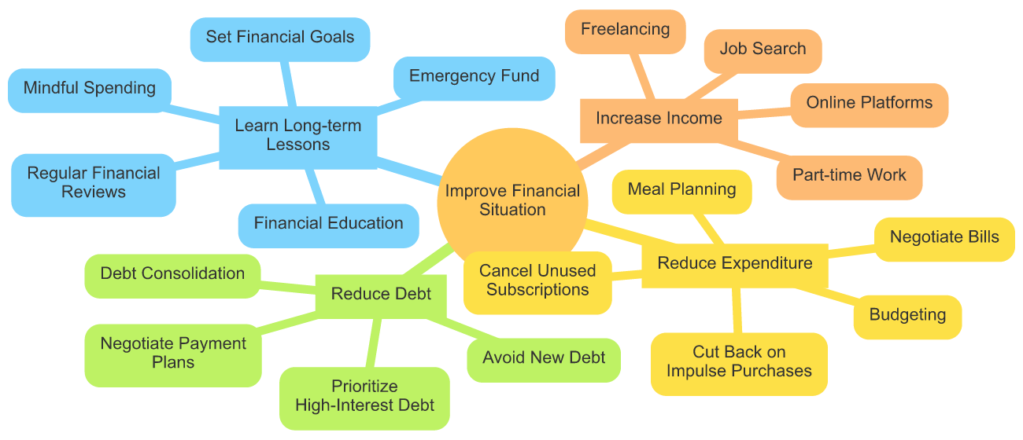

### ✅ Example

|  |  |
| --- | --- |
| Mistakes | How could the person have done better? |
| Not actively seeking ways to increase income | Engage in job search, freelancing, or part-time work to boost income. |
| Lack of budgeting and tracking expenses | Create a detailed budget to monitor spending and identify unnecessary expenses. |
| Keeping unused subscriptions | Cancel unused subscriptions and memberships to save money. |
| Impulse purchases and discretionary spending | Set limits on discretionary spending and prioritize needs over wants. |
| Not negotiating bills | Negotiate with service providers for lower rates or explore cheaper alternatives. |
| Accumulating high-interest debt | Prioritize paying off high-interest debts and consider consolidating debts. |
| Not building an emergency fund | Start saving for an emergency fund to cover unexpected expenses. |
| Lack of financial education | Engage in financial education through courses or books to improve money management skills. |