# Different religious holidays

Can you match the holidays to the different religions?

|  |  |  |
| --- | --- | --- |
| Buddhism | Islam | Christianity |
| Judaism | Hinduism |

Passover · Kathina · Easter · Pentecost · Navaratri · Eid al-Fitr · Yom Kippur · Eid al-Adha · Vesak · Rosh Hashanah · Diwali · Mawlid al-Nabi · Christmas · Hanukkah · Ramadan · Magha Puja · Good Friday · Asalha Puja · Holi · Maha Shivaratri

# Religious holidays in one religion

What holidays do you know that are celebrated in Judaism?

___________________________________________________________________

___________________________________________________________________

___________________________________________________________________

|  |
| --- |
| Class discussion Do you celebrate one or more of these holidays? If so, tell the rest of the class how and with whom you celebrate. |

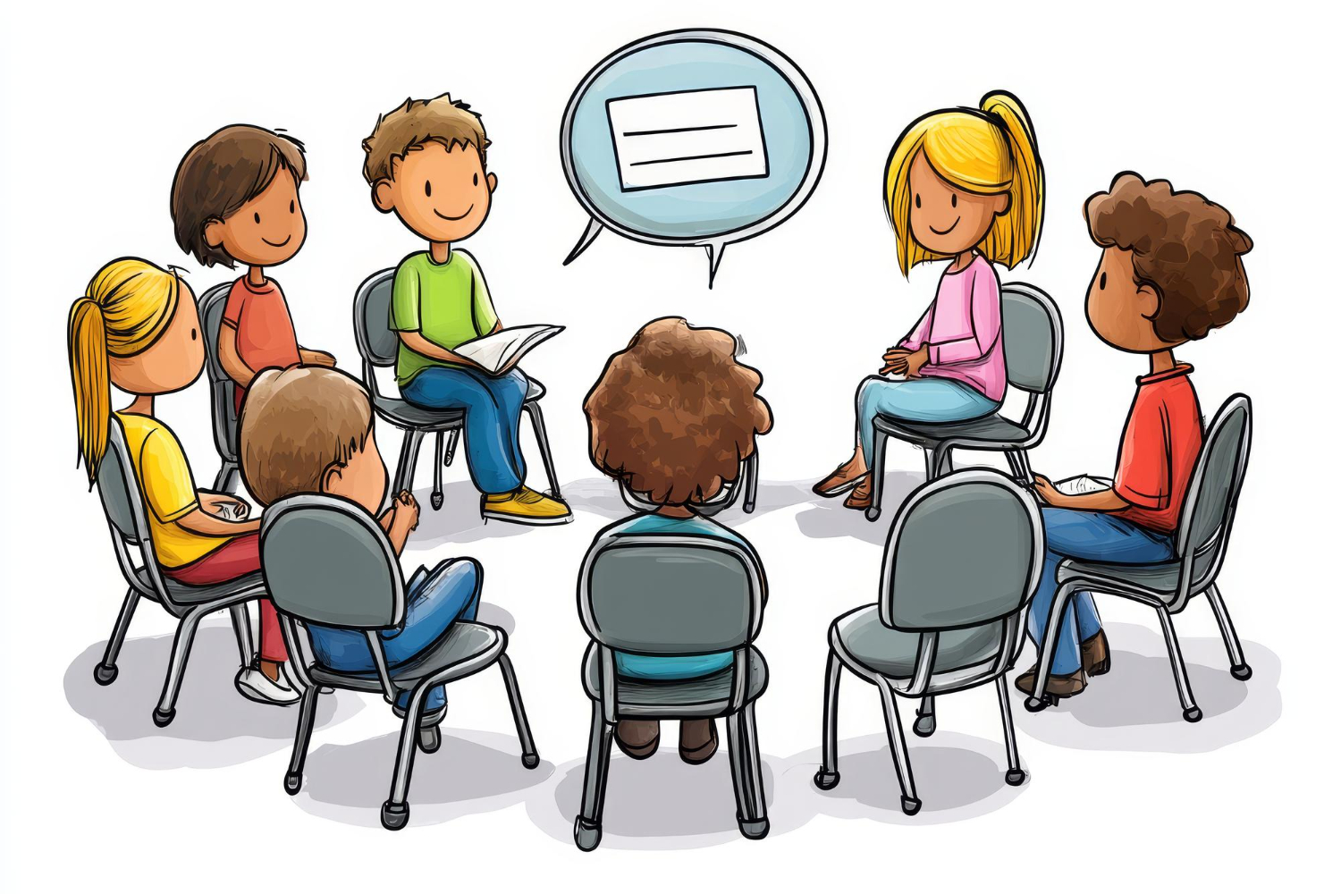

|  |
| --- |
| Information about the holiday Read the following text where you learn about a religious holiday. Then fill out the profile on the following page. |

# Hanukkah

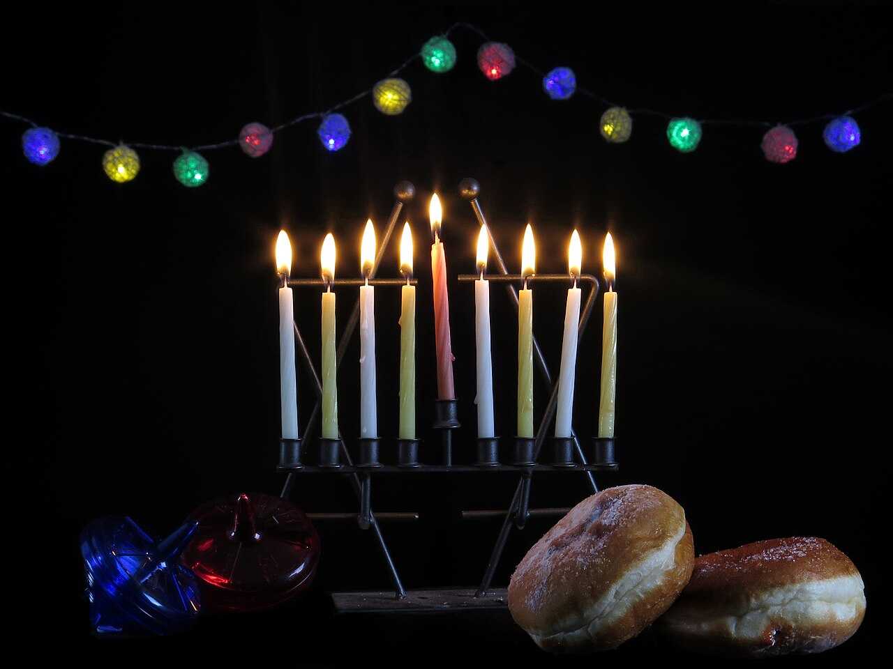

YB13D on Wikimedia Commons

Source:

Hanukkah is a special holiday celebrated by Jewish people around the world. It usually takes place in late November or December and lasts for eight nights and days. The exact dates change every year because the Jewish calendar is different from the one most people use daily.

Hanukkah is celebrated in many countries, including Israel, the United States, Canada, and many European countries. Families and friends come together to remember the miraculous event that happened a long time ago in Jerusalem.

One of the main traditions of Hanukkah is lighting the menorah, a special candle holder with nine branches. Each night, one more candle is lit until all eight candles, plus the helper candle called the shammash, are glowing. This is done to remember the miracle when a small amount of oil kept the menorah in the ancient Temple of Jerusalem lit for eight days, even though it seemed like there was only enough oil for one day.

During Hanukkah, people sing songs, play games, and enjoy delicious foods. One popular game is dreidel, a spinning top with four sides. Each side has a Hebrew letter, and depending on which side lands facing up, players either win or lose chocolate coins or other small treats.

Eating special foods is a big part of Hanukkah celebrations. People eat foods fried in oil, like latkes (potato pancakes) and sufganiyot (jelly-filled doughnuts), to remember the miracle of the oil.

Hanukkah is especially fun for children. They often receive gifts each night, and some families give "Hanukkah gelt," which can be real coins or chocolate coins wrapped in gold foil. Kids also love playing with dreidels and enjoying the special foods prepared during the holiday.

Hanukkah is a time for joy, family, and remembering miracles. It's a celebration of light, hope, and resilience that brings people together, making it a very special time of the year.

|  |  |
| --- | --- |
|  | Name of the holiday |
| When is the holiday celebrated? |
| In which countries is the holiday celebrated? |
| How is the holiday celebrated? | |
| Which traditions are associated with the holiday? | |
| Traditions particularly for children | |

# Additional information for teachers

|  |  |
| --- | --- |
|  | Name of the holiday  Hanukkah |
| When is the holiday celebrated?  Hanukkah usually takes place in late November or December and lasts for eight nights and days. The exact dates change every year because the Jewish calendar is different from the one most people use daily. |
| In which countries is the holiday celebrated?  Hanukkah is celebrated in many countries, including Israel, the United States, Canada, and many European countries. |
| How is the holiday celebrated?  Families and friends come together to remember the miraculous event that happened a long time ago in Jerusalem. People light the menorah, sing songs, play games, and enjoy delicious foods. | |
| Which traditions are associated with the holiday?  One of the main traditions is lighting the menorah, a special candle holder with nine branches. Each night, one more candle is lit until all eight candles, plus the helper candle called the shammash, are glowing. A popular game is dreidel, a spinning top with four sides. People also eat foods fried in oil, like latkes (potato pancakes) and sufganiyot (jelly-filled doughnuts). | |
| Traditions particularly for children  Children often receive gifts each night and some families give "Hanukkah gelt," which can be real coins or chocolate coins wrapped in gold foil. Kids also love playing with dreidels and enjoying the special foods prepared during the holiday. | |