|  |
| --- |
| The 17 Sustainable Development Goals Also known as the Sustainable Development Goals (SDGs), the 17 goals were set by the United Nations in 2015. They are a global plan to create a better and more sustainable future for all by 2030. These goals are aimed at all countries and are intended to tackle pressing challenges such as poverty, inequality and environmental protection.      Global cooperation:  All countries should work together to achieve these goals.    Diversity of issues:  The goals include social, economic and environmental aspects.    Responsibility:  Every individual, every community and every country has a responsibility to contribute.    Long-term vision:  The goals are intended for the future in order to create sustainable solutions.      The SDGs are important because they give a clear direction on how we can improve the world. They are a call for everyone to take action and bring about change. |

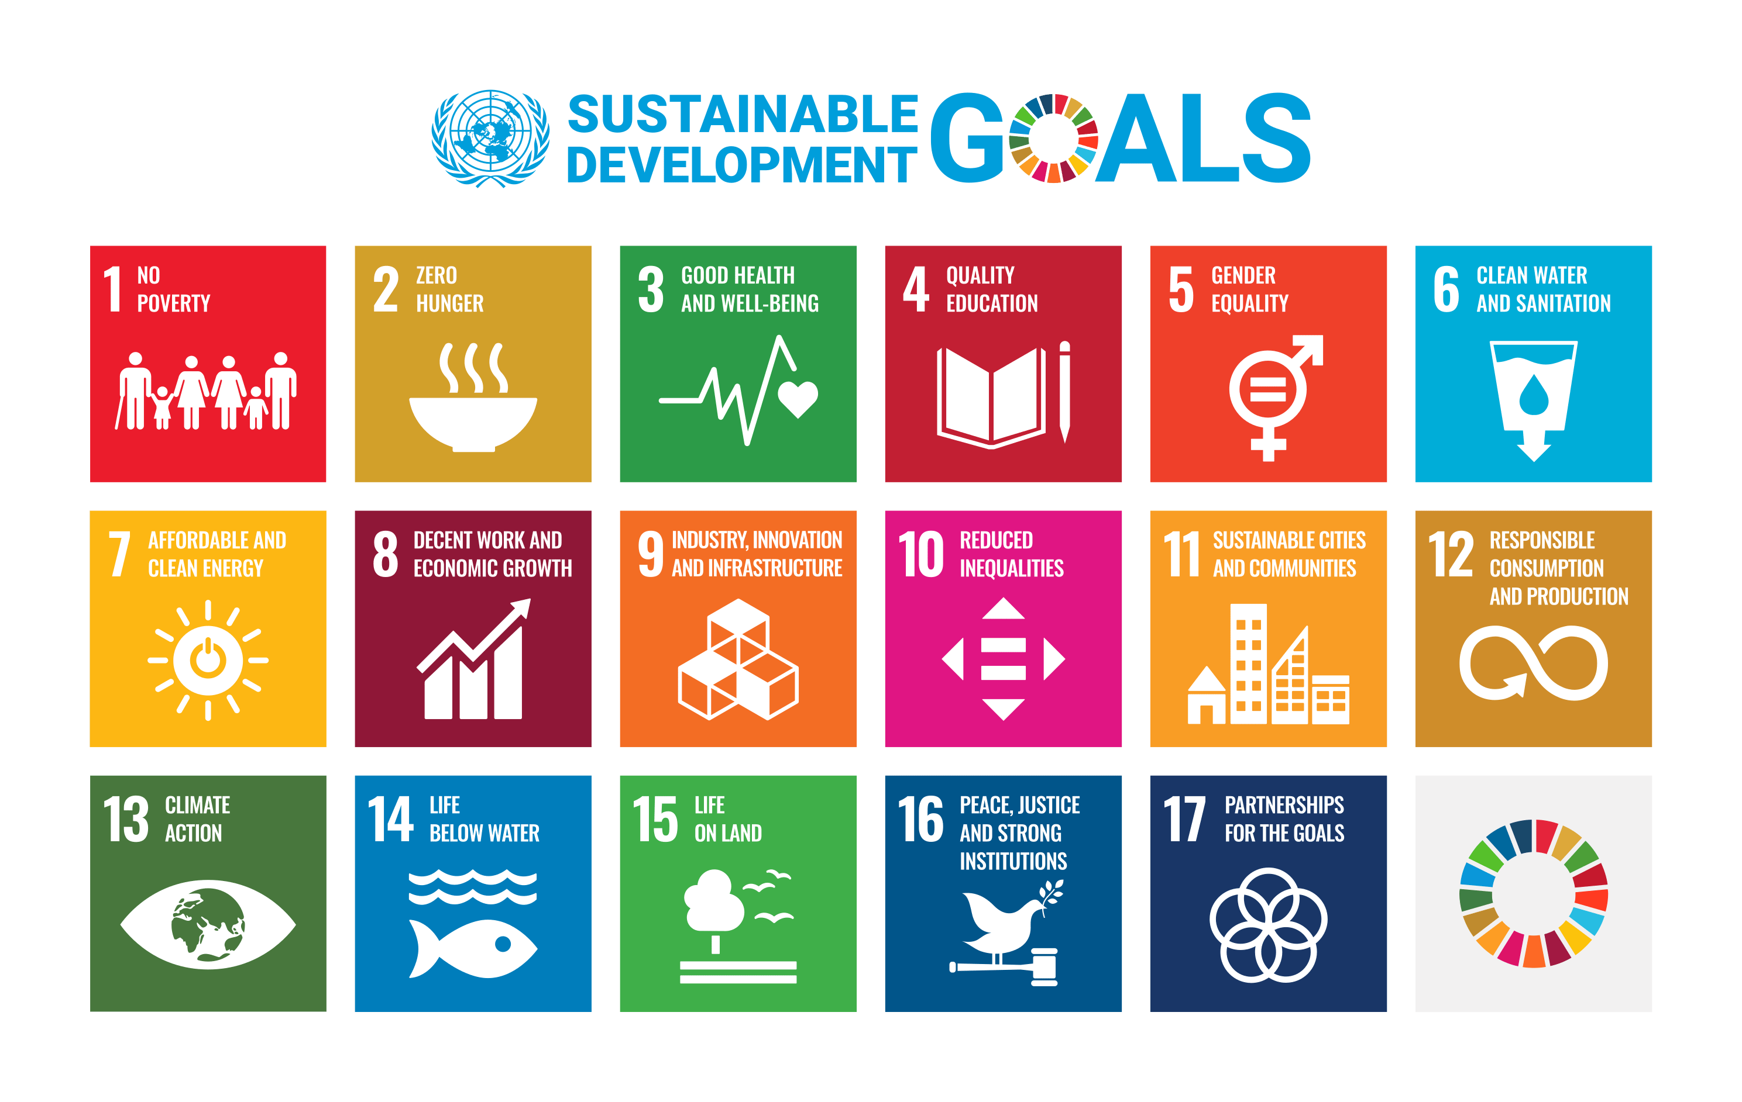

Sustainable Development Goals (SDGs)

You will now learn more about one of the Sustainable Development Goals!

### 📋 Work assignment

Read the info text carefully and then complete the task.

### Goal 1: No Poverty

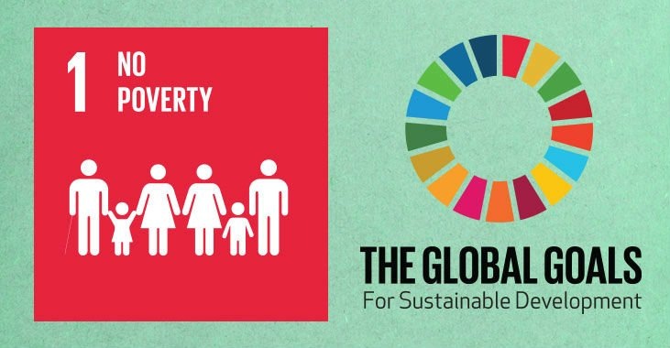

Understanding 'No Poverty' for Sustainable Development
The United Nations Sustainable Development Goal 1, known as "No Poverty," aims to end poverty in all its forms everywhere by 2030. This goal is crucial because poverty affects millions of people worldwide, limiting their access to essential resources like food, clean water, and education. It also impacts their health and overall well-being.

Ideal State and Purpose

Imagine a world where no one lives on less than $2.15 a day, the benchmark for extreme poverty. The ultimate aim is to create societies where everyone has equal opportunities to thrive, regardless of their background or economic status. Achieving this goal requires addressing the root causes of poverty, such as lack of access to education, health care, and employment opportunities.

Why the Goal Matters

Human Rights and Equality

: Poverty eradication is not just an act of charity; it's a matter of justice and fundamental human rights. Everyone deserves a fair chance to succeed and live with dignity.

Impact on Other Goals

: Ending poverty is interconnected with other SDGs, such as Zero Hunger and Quality Education. When people are lifted out of poverty, they have better access to food and education, leading to healthier lives and empowered communities.

Global Stability

: Reducing poverty contributes to global peace and security. It helps prevent conflicts that arise from inequality and lack of resources.

Key Targets

Eradicate Extreme Poverty

: By 2030, aim to eliminate extreme poverty for all people everywhere.

Reduce Overall Poverty

: Cut the poverty rate by half, ensuring equitable access to economic resources and opportunities.

Social Protection Systems

: Implement systems that support the vulnerable, ensuring they have access to essential services.

### 📋 Select the correct answer from the options provided.

###### **What is the ultimate aim of the 'No Poverty' goal by 2030?**

To ensure everyone lives on more than $2.15 a day To provide free education for all To eliminate hunger worldwide To increase global security forces

###### **How can reducing poverty contribute to global peace?**

It prevents conflicts from inequality and resource scarcity It increases military spending It reduces international travel It promotes language learning

###### **Why is poverty eradication considered a matter of justice?**

Because everyone deserves a fair chance to succeed Because it increases government revenue Because it reduces the cost of living Because it improves weather conditions

###### **What is one of the key targets of the 'No Poverty' goal?**

Implementing social protection systems for the vulnerable Developing new sports facilities worldwide Creating universal health insurance Building more highways

###### **How does ending poverty impact other Sustainable Development Goals?**

It improves access to food and education It decreases water pollution It increases urbanization It leads to higher energy consumption

Okay, now you've learnt a lot about a Sustainable Development Goal and what it entails. Now it's time to take a look at how well the goal has already been achieved!

### 📋 Assignment

Read through the info text and then complete the tasks.

# Progress on 'No Poverty': Achievements and Challenges

## Current Status of SDG 1

As of 2023, the world continues to grapple with significant challenges in achieving Sustainable Development Goal 1, No Poverty. Despite previous progress, the goal of eradicating extreme poverty by 2030 remains aspirational. The international poverty line, now set at $2.15 per day, serves as a critical measure. Projections suggest that approximately 575 million people will still live in extreme poverty by 2030, highlighting the need for intensified efforts to combat poverty globally.

The COVID-19 pandemic dealt a severe blow to poverty reduction efforts, reversing years of progress. In 2020, the number of people living in extreme poverty increased by about 70 million, marking a substantial setback. This rise underscores the vulnerability of global economies to unforeseen crises, emphasizing the urgent need for resilient social protection systems and economic growth strategies that prioritize the poorest nations.

## Financial Investments and Likelihood of Success

Financial investments are pivotal in advancing poverty eradication initiatives. Official development assistance (ODA) targeting poverty reduction plays a crucial role, demanding increased and strategic implementation to make a significant impact. Moreover, the goal emphasizes pro-poor and gender-sensitive policy frameworks to support accelerated investment in poverty eradication actions.

Despite substantial efforts and investments, achieving SDG 1 by 2030 seems unlikely under current circumstances. Historical trends indicate that less than a third of countries worldwide may halve poverty by the target year. To improve these odds, nations must intensify their efforts, enhance cooperation, and mobilize resources effectively.

In conclusion, while strides have been made, the path to eradicating poverty is fraught with challenges. The commitment to SDG 1 remains strong, but it demands a concerted global effort to overcome obstacles and ensure a future where poverty is no longer a barrier to human dignity and equality.

### 📋 Write a short text on the given question.

What are some challenges the world faces in achieving the goal of 'No Poverty' by 2030?

___________________________________________________________________

___________________________________________________________________

___________________________________________________________________

Considering the current status of efforts to eradicate poverty, what steps should countries take to improve the likelihood of achieving SDG 1 by 2030?

___________________________________________________________________

___________________________________________________________________

___________________________________________________________________

## 💡 Bonus

### Checklist for everyday life

Create a checklist with specific behaviours that contribute to one or more sustainability goals in everyday life. To find out more about the other goals, you can watch the following video and read information on the website of the 17 Sustainable Development Goals.

Try to formulate as many concrete behaviours as possible and challenge yourself in your everyday life!

Examples:

Goal 12 (sustainable consumption): "I buy products with less packaging." / "I repair things instead of throwing them away."

Goal 13 (climate protection): "I walk short distances or cycle." / "I make sure to save energy."

|  |  |
| --- | --- |
|  | Youtube: UN Sustainable Development Goals - Overview  To watch the youtube video just scan the QR code.  https://www.youtube.com/watch?v=M-iJM02m_Hg |

|  |  |
| --- | --- |
| THE 17 GOALS | Sustainable Development  Do you know all 17 SDGs?HistoryThe 2030 Agenda for Sustainable Development, adopted by all United Nations Member States in 2015, provides a shared blueprint for peace and prosperity for people and the planet,... |  |

### ✒️ Checklist

___________________________________________________________________

___________________________________________________________________

___________________________________________________________________

___________________________________________________________________