Definition of Independence and Independence Movements

Independence:
The condition of a nation, country, or state in which its residents and population, or some portion thereof, exercise self-government, and usually sovereignty, over its territory.

Independence Movements:
Political and social movements that seek to achieve independence for a country or region that they believe is under foreign control or colonial rule.

Example:
The Indian National Congress led the independence movement against British rule, employing strategies like non-violent protests and civil disobedience, eventually leading to India's independence in 1947.

Pre-Independence Situation in India

Political Situation

Before gaining independence in 1947, India was under British colonial rule. The British East India Company initially established control in the 18th century, which was later transferred to the British Crown in 1858 following the Revolt of 1857. The British administration implemented policies that centralized authority and introduced Western legal and education systems. Indian representation was minimal, and political power was predominantly in the hands of British officials.

Social Situation

Indian society was characterized by a complex caste system, significant religious diversity, and regional differences. British policies often exacerbated social divisions. The introduction of Western education led to the rise of an educated middle class that began to challenge colonial rule. Social reform movements emerged, addressing issues such as caste discrimination, women's rights, and religious reform.

Economic Situation

The Indian economy was primarily agrarian, with the majority of the population engaged in agriculture. British economic policies aimed at benefiting the colonial power resulted in deindustrialization and economic stagnation. The imposition of heavy taxes, exploitation of resources, and disruption of traditional industries such as textiles led to widespread poverty and famines.

Nationalist Movements

The late 19th and early 20th centuries saw the rise of nationalist movements. The Indian National Congress, founded in 1885, became a major force advocating for self-rule. Leaders like Mahatma Gandhi, Jawaharlal Nehru, and Subhas Chandra Bose played pivotal roles. The struggle included non-violent protests, civil disobedience, and movements like the Quit India Movement in 1942.

Conclusion

The pre-independence period in India was marked by British colonial dominance, social stratification, economic exploitation, and burgeoning nationalist sentiments. These factors collectively set the stage for India's eventual struggle for and attainment of independence in 1947.

Voices of independence
Mahatma Gandhi  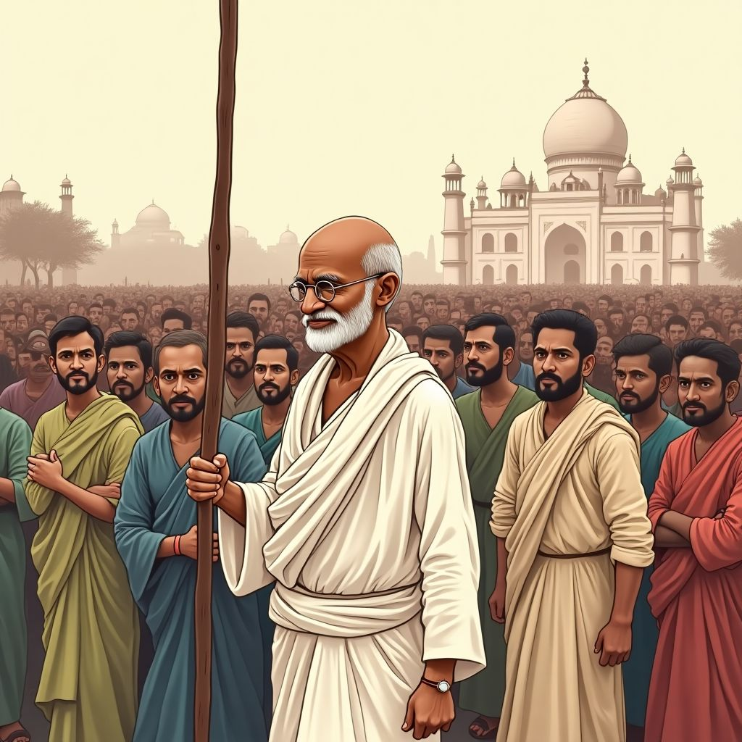  Role: Leader of the Indian independence movement and advocate of non-violent resistance.  Actions:  - Lead non-violent protests and civil disobedience campaigns.  - Promote the principles of self-reliance and simplicity through the Swadeshi movement.  - Mediate conflicts between different religious and social groups.  - Engage in hunger strikes to draw attention to injustices and demand policy changes.  Mahatma Gandhi is a pivotal figure in India's fight for independence, embodying the principles of non-violence and civil disobedience. | Jawaharlal Nehru  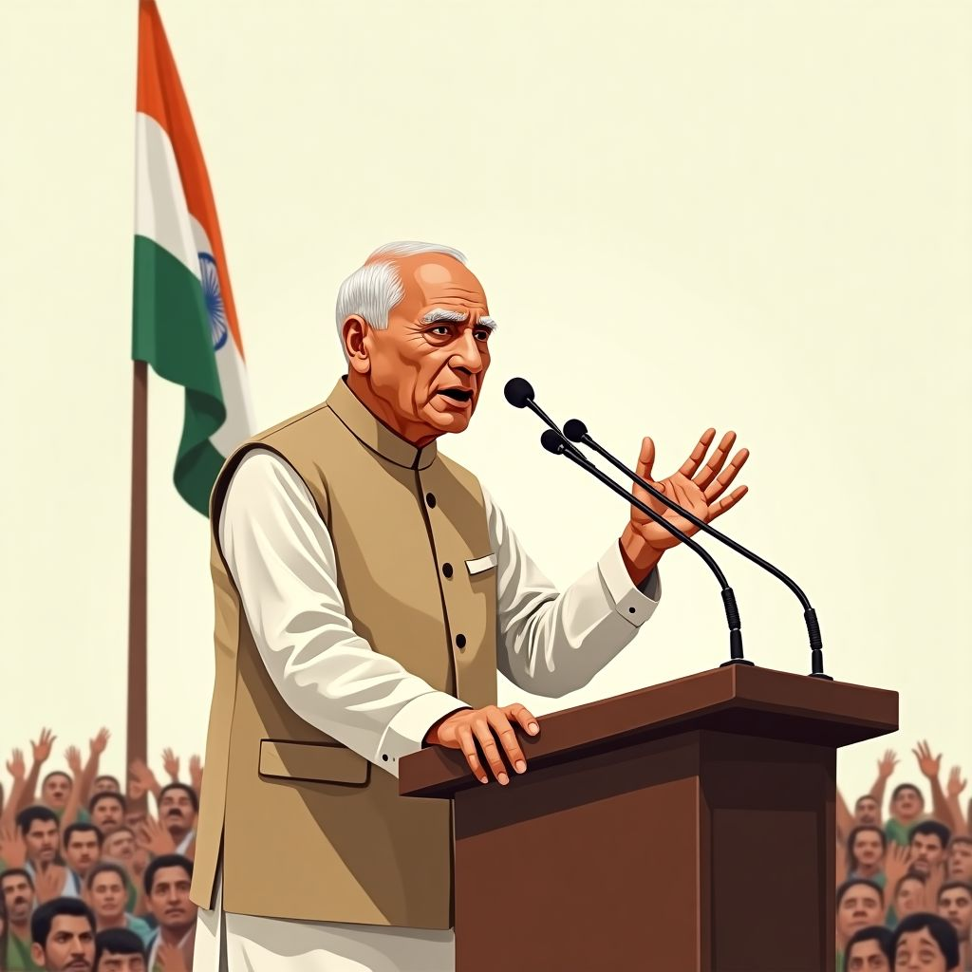  Role: Prominent leader in the Indian independence movement and the first Prime Minister of independent India.  Actions:  - Advocate for modern education and industrialization as means to strengthen India's future.  - Work closely with Gandhi and other leaders to strategize the independence movement.  - Represent India in international forums to garner support for the independence cause.  - Write extensively to inspire and educate the masses about the vision for an independent India.  Jawaharlal Nehru is a key architect of modern India, striving for a balanced approach to development and social justice.

Be the voice

Prepare a short monologue or speech that captures the motivations, challenges, and vision for independence of Jawaharlal Nehru based on the provided text.

___________________________________________________________________

___________________________________________________________________

___________________________________________________________________

___________________________________________________________________

After the movement
 | Audio Content  To listen to audio content just scan the QR code and listen to it on the digital worksheet.  https://to-teach.ai/worksheet/iWldclzkttsTMjDxsNPV

Evaluate the economic transformation of India from the pre-independence period to the post-independence period.
___________________________________________________________________
___________________________________________________________________
___________________________________________________________________
Explain the changes in the political landscape of India from the colonial period to the present day.
___________________________________________________________________
___________________________________________________________________
___________________________________________________________________

