# Discover the world of interviews - This is how we truly get to know people!

|  |
| --- |
| Why are interviews so exciting? Imagine you could look into the thoughts of other people. What would they be thinking? How do they see the world? Interviews are like a window into the lives of others - and you can open that window a little bit! |

# Social science interviews

Read the following info box to learn more about interviews in the field of social sciences.

|  |
| --- |
| What is a social science interview? Definition    A social science interview is a conversation in which one person (the interviewer) asks another person (the interviewee) questions to learn more about their experiences, opinions, and feelings.      Why are interviews conducted?    Social scientists use interviews to learn more about people and their stories. It helps to gain a better understanding of different perspectives and cultures.      Examples of interviews in practice    A journalist interviews a politician about current issues.  A sociologist talks to young people about their visions for the future.  An anthropologist interviews villagers about their traditional festivals. |

Discussion: In small groups, think about why people like to tell their stories and what can be discovered through an interview. Write down three possible reasons.

___________________________________________________________________

___________________________________________________________________

___________________________________________________________________

# Conducting a social science interview

Imagine you want to conduct an interview in civics / social sciences / social studies or similar. What are important terms that come to mind on the topic? What do you need to pay attention to? Make notes, then create a mind map together with the rest of the class.

___________________________________________________________________

___________________________________________________________________

___________________________________________________________________

# Additional information for teachers

Sample solution for the mind map

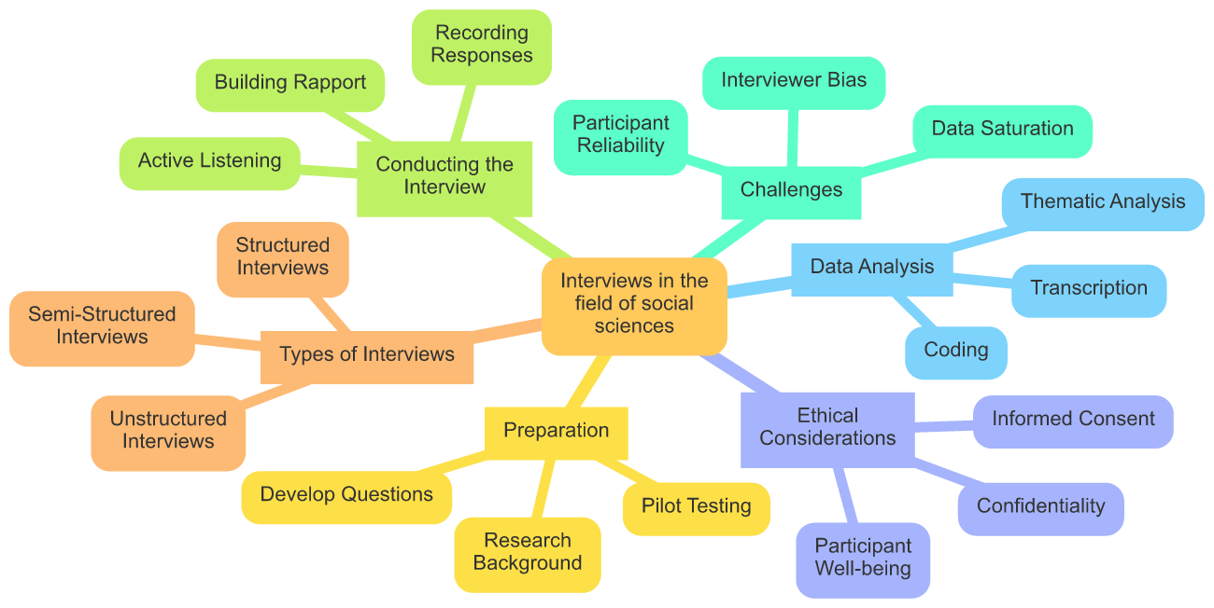

# How do I conduct an interview?

Watch the following video, then answer the corresponding questions.

|  |  |
| --- | --- |
|  | Youtube: How to Conduct an Interview  To watch the youtube video just scan the QR code.  https://www.youtube.com/watch?v=kO9WcdINoRk |

### Choose the correct answer for each question.

###### **What is the first step in the interview process according to the video?**

Getting your subject to agree to the interview Choosing a quiet interview location Drafting a list of questions Researching the interview subject

###### **Why is it important to ask open-ended questions during an interview?**

They make the interview shorter They are easier to record They help maintain eye contact They prompt more detailed answers

###### **What should you do if your subject agrees to the interview?**

Share your questions in advance Send them a thank-you card Immediately start the interview Set up a time and place that is convenient for them

###### **How can you make your interviewee feel comfortable and more likely to open up?**

Avoid asking personal questions Start with the most difficult questions Conduct the interview in a noisy place Establish a friendly rapport and make eye contact

###### **Why is it critical to listen carefully during an interview?**

So you can write down every word To avoid missing the chance to ask important follow-up questions To ensure the interview does not exceed the time limit To make sure the recording device is working

###### **What should you do if the subject gives an answer that inspires a new question?**

Ignore the new question and move on End the interview immediately Stick strictly to your original list of questions Ask the new question to get more detailed information

###### **What is an appropriate way to start an interview?**

By complimenting the interviewee and making small talk By jumping straight into sensitive topics By asking for their resume By giving them a list of your questions

###### **What is a good practice to follow after the interview is completed?**

Publish the interview without review Ask them for more interviews immediately Send the interviewee a thank-you card Never contact the interviewee again



# Different types of interviews

|  |
| --- |
| Structured interview The interviewer has a fixed list of questions that are asked in a specific order.   Unstructured interview   The conversation is open, and the interviewer responds flexibly to the interviewee's answers.   Semi-structured interview A mix of both: There are some prepared questions, but also room for spontaneous questions. |

# Group task: Match the interview type to the topics

Read through the different types of interviews and then decide for each topic which interview type is most suitable:

Topic 1: "The Impact of Social Media on Teenagers"

Topic 2: "The Story of a World War II Eyewitness"

Topic 3: "Students' Opinions on Healthy Eating in School"

Now, write down the appropriate interview type and a brief justification for each topic.

Topic 1

___________________________________________________________________

___________________________________________________________________

___________________________________________________________________

Topic 2

___________________________________________________________________

___________________________________________________________________

___________________________________________________________________

Topic 3

___________________________________________________________________

___________________________________________________________________

___________________________________________________________________

# Conducting an interview

Imagine you are conducting an interview on the topic of 'Harry Potter.' Note down whom you would interview and what questions you would like to ask the person (at least three questions).

___________________________________________________________________

___________________________________________________________________

___________________________________________________________________

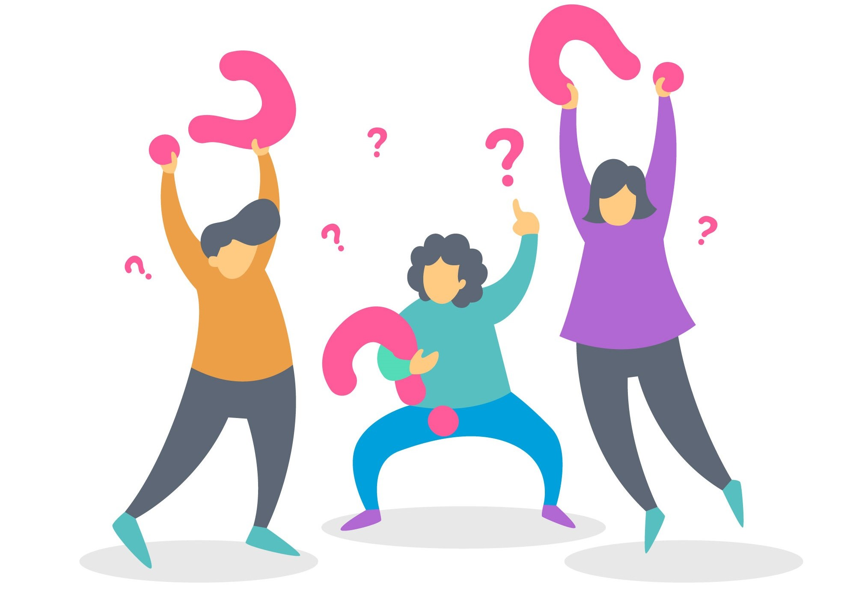

# Reflection - What makes a good interview?

What does an interviewer need to conduct a good interview? Write down three important skills or qualities. Discuss your results afterwards in class.

___________________________________________________________________

___________________________________________________________________

___________________________________________________________________

