Luke Skywalker  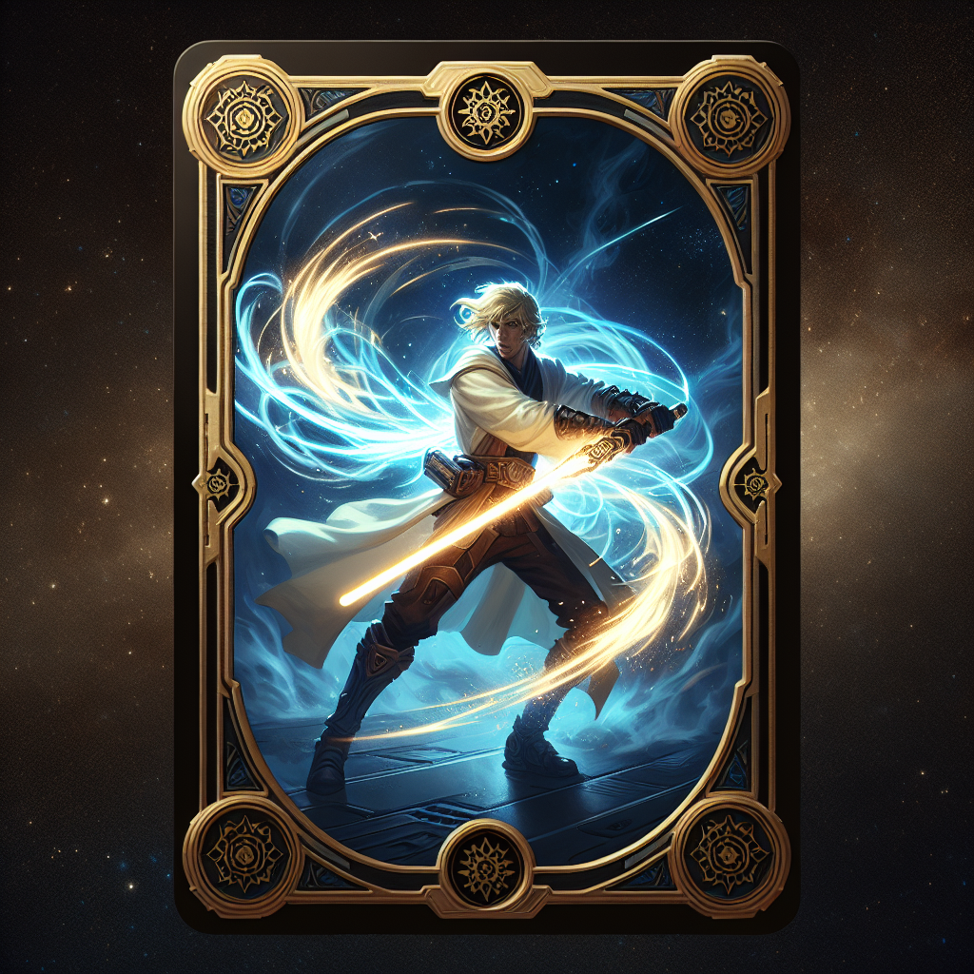  Force Ability: 14  Battle Skills: 12  Leadership: 10  Luck: 11  Luke Skywalker is a Jedi Knight, the son of Anakin Skywalker, and key to the Rebellion's victory. | Leia Organa  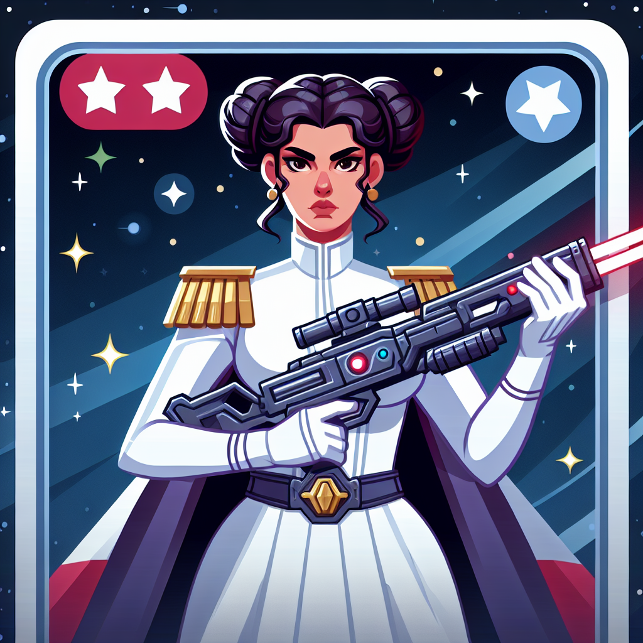  Force Ability: 8  Battle Skills: 9  Leadership: 13  Luck: 12  Leia Organa is a fearless leader of the Rebel Alliance and the twin sister of Luke Skywalker. | Han Solo  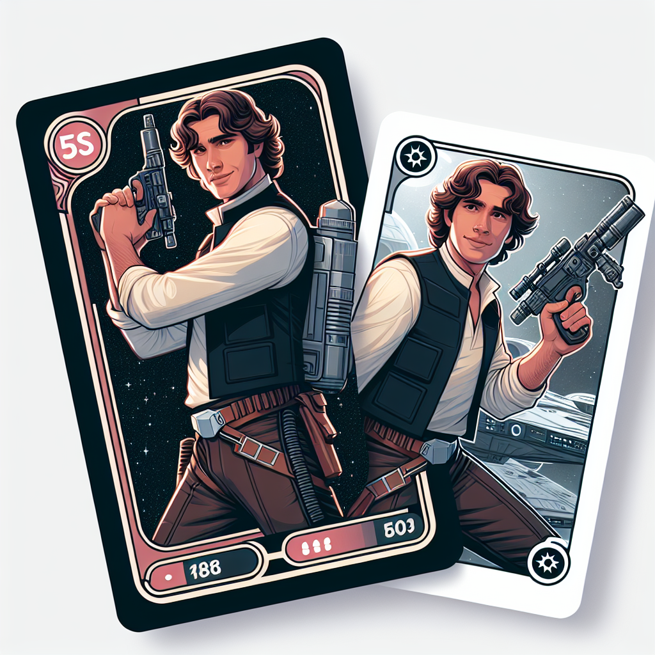  Force Ability: 5  Battle Skills: 10  Leadership: 7  Luck: 14  Han Solo is a skilled pilot, smuggler, and key ally to the Rebel Alliance.

Answer the questions and compare the characters.
Who has stronger leadership skills, Princess Leia or Luke Skywalker, and why?
___________________________________________________________________
Between Han Solo and Princess Leia, who is luckier and what do their scores tell us?
___________________________________________________________________
Compare the battle skills of Han Solo and Luke Skywalker, who is more skilled?
___________________________________________________________________
Who has a higher force ability, Princess Leia or Han Solo, and by how much?
___________________________________________________________________
Looking at their scores, who would you say is the most well-rounded character and why?
___________________________________________________________________

Use a lot of comparative adjectives

Compare the leadership qualities of Princess Leia and Luke Skywalker in terms of their decision-making abilities.
___________________________________________________________________
___________________________________________________________________
___________________________________________________________________
Explain how the backgrounds of Han Solo and Princess Leia might influence their approaches to problem-solving.
___________________________________________________________________
___________________________________________________________________
___________________________________________________________________
Argue who might be more adaptable to unexpected challenges, Luke Skywalker or Han Solo, based on their experiences.
___________________________________________________________________
___________________________________________________________________
___________________________________________________________________

