### When you think of famous philosophers, which names come to your mind?

___________________________________________________________________

___________________________________________________________________

___________________________________________________________________

___________________________________________________________________

### Collect your results in class. What do you notice?

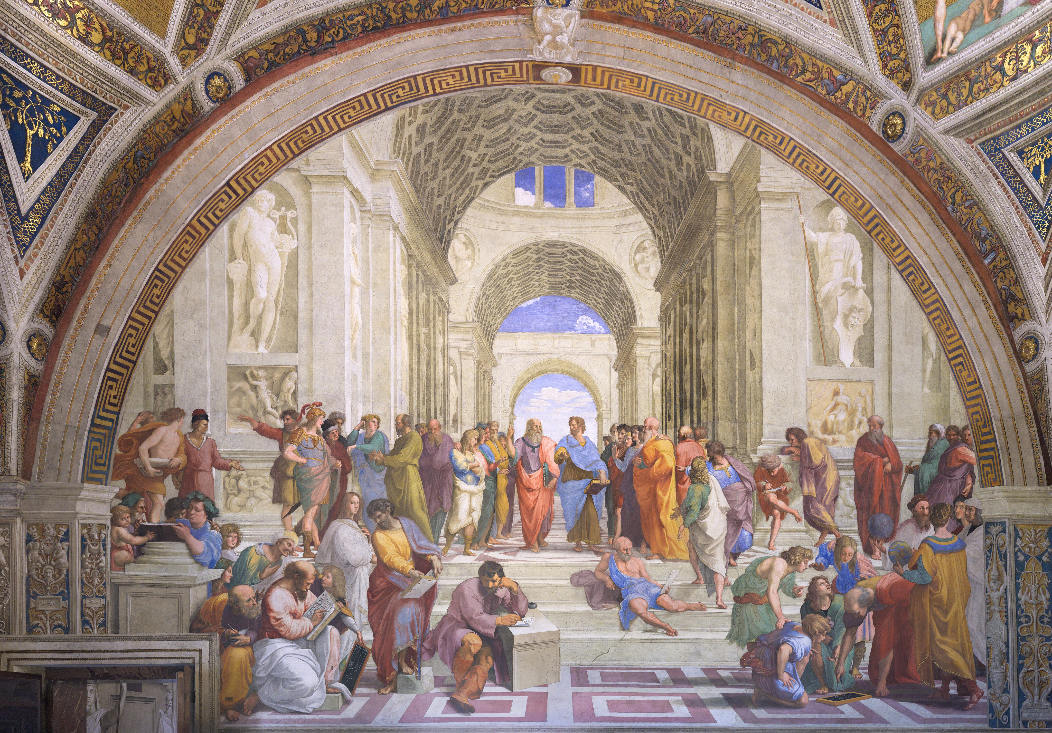

Raphael: "The School of Athens"

|  |
| --- |
| Philosophers of the World As you have probably noticed, most of the philosophers we encounter in school and daily life are male and belong to our Western cultural tradition. But that is only a small part of the philosophical world! There are many other philosophers from different cultures who have developed exciting and important ideas. That’s why this worksheet focuses on thinkers who are often less well-known but whose perspectives are just as fascinating and meaningful. |

# The World of Islamic Philosophers

Islamic philosophy is a fascinating and rich tradition that emerged from the Islamic world, blending religious beliefs with logical reasoning, mathematics, and sciences. This blend, often referred to as "falsafa" (philosophy) and "kalam" (theology), sought to understand the universe, existence, and the nature of God.

The journey of Islamic philosophy began during the Golden Age of Islam, roughly from the 8th to the 12th centuries. This era saw the rise of great thinkers like Al-Kindi, who is often considered the first Islamic philosopher, and Al-Farabi, who was known for his works on political philosophy and metaphysics. This period also saw the works of Avicenna (Ibn Sina) and Averroes (Ibn Rushd). These philosophers were heavily influenced by Greek philosophy, particularly Aristotle and Plato, and they sought to harmonize this with Islamic teachings.

Islamic philosophy dealt with several central themes, including the nature of God, the creation of the universe, the soul, and ethics. Philosophers explored questions about free will and predestination, the existence of an afterlife, and the nature of knowledge and truth. They also made significant contributions to science, medicine, and mathematics, influencing the intellectual landscape of both the Islamic world and medieval Europe.

Despite facing opposition from some religious scholars who believed that philosophy could lead to heresy, Islamic philosophers managed to leave a lasting legacy. Their works were translated into Latin and Hebrew, impacting European thought and playing a crucial role in the Renaissance.

Islamic philosophers were not just confined to religious and metaphysical questions; they also engaged deeply with practical issues, including politics, ethics, and education. Their intellectual pursuits laid the groundwork for many modern scientific and philosophical ideas, demonstrating the timeless quest for knowledge and understanding.

Explain the influence of Greek philosophy on Islamic philosophers during the Golden Age of Islam.

___________________________________________________________________

___________________________________________________________________

___________________________________________________________________

|  |  |  |
| --- | --- | --- |
| Al-Farabi    Al-Farabi was an early Islamic philosopher and music theorist known as the 'Second Master' after Aristotle. His philosophical interests were wide-ranging, including political philosophy, philosophy of religion, logic, psychology, metaphysics, ethics, and music theory. Al-Farabi is credited with presenting philosophy as a coherent system in the Islamic world and creating a philosophical framework that extended beyond the scholastic interests of his Greco-Roman and Syriac Aristotelian predecessors. His works incorporated elements of Neoplatonism and Aristotelianism, influencing later Islamic philosophers such as Avicenna and Averroes.  Abu Nasr Muhammad al-Farabi (c. 870 – 950), known in the Latin West as Alpharabius, was a pioneering philosopher during the Islamic Golden Age. He spent much of his scholarly life in Baghdad and later in Damascus. Al-Farabi's notable works include 'Kitab al-Musiqi al-Kabir' (Grand Book of Music) and 'Ara Ahl al-Madina al-Fadila' (Virtuous City). He is regarded as the 'Father of Islamic Neoplatonism' and the 'Founder of Islamic Political Philosophy.' | Avicenna    Avicenna, also known as Ibn Sina, was a Persian polymath who made significant contributions to various fields including philosophy, medicine, and science. His philosophical writings were heavily influenced by Aristotelianism, and he sought to reconcile it with Islamic thought. Avicenna's 'Book of Healing' and 'The Canon of Medicine' are among his most notable works, with the latter becoming a standard medical text in medieval European universities. Avicenna's philosophy emphasized the distinction between essence and existence and developed a Neoplatonic scheme of emanation that became fundamental in Islamic metaphysics.  Ibn Sina (c. 980 – 1037), commonly known as Avicenna, was a renowned philosopher and physician during the Islamic Golden Age. Born in Afshana near Bukhara, he served in various Iranian courts and is often described as the father of early modern medicine. Avicenna's extensive corpus includes writings on astronomy, alchemy, psychology, and Islamic theology. He wrote most of his works in Arabic, with some key works in Persian. His ideas influenced both Islamic and European medieval philosophy, particularly in the areas of metaphysics and epistemology. | Averroes    Averroes, known in the Muslim world as Ibn Rushd, was an Andalusian polymath who wrote extensively on philosophy, theology, medicine, and law. He is best known for his commentaries on Aristotle, which significantly influenced Western thought. Averroes argued for the compatibility of philosophy and Islam, asserting that reason and revelation are not contradictory. His works on Islamic jurisprudence, such as 'Bidayat al-Mujtahid,' analyze the differences between Islamic legal schools and their principles. In medicine, his 'Colliget' became a textbook in Europe, and he made significant contributions to the understanding of the retina and stroke.  Ibn Rushd (1126 – 1198), often Latinized as Averroes, was a philosopher and jurist from Al-Andalus. Born in Córdoba, he served as a judge and court physician in Marrakesh. Averroes's philosophical works aimed to restore Aristotle's teachings and defend the pursuit of philosophy against theological criticism. His commentaries on Aristotle's works were translated into Latin, reawakening Western European interest in Greek philosophy. Despite his temporary fall from favor, Averroes's ideas continued to influence both Islamic and Western thought, particularly through the philosophical movement known as Averroism. |

### Tick the correct answer.

###### **Which Islamic philosopher is known for his theory of the 'Floating Man'?**

Avicenna Al-Farabi Averroes

###### **What did Al-Farabi's work 'Al-Madina al-Fadila' focus on?**

The harmony between religion and philosophy A perfect society governed by virtuous leaders The nature of the soul

###### **Why did some religious scholars oppose Islamic philosophers?**

They saw philosophy as incompatible with science They thought philosophy was irrelevant to practical issues They believed philosophy could lead to heresy

###### **How did Averroes contribute to the transmission of Aristotelian philosophy?**

By writing 'Kitab al-Musiqi al-Kabir' By creating commentaries on Aristotle's works By writing 'The Canon of Medicine'

###### **What was Avicenna's 'The Canon of Medicine' known for?**

Exploring the therapeutic and ethical aspects of music Being a standard medical text in Europe and the Islamic world Outlining a vision of a perfect society

###### **What did Islamic philosophy aim to harmonize with Islamic teachings?**

Chinese philosophy Indian philosophy Greek philosophy

###### **Which philosopher is referred to as 'The Commentator'?**

Al-Farabi Avicenna Averroes

###### **What did Islamic philosophers explore in addition to religious and metaphysical questions?**

Practical issues like politics, ethics, and education Mathematics and astronomy Theology and mysticism

Try to find out in 2–3 sentences what the person's most important idea or contribution to the philosophy is.

___________________________________________________________________

___________________________________________________________________

___________________________________________________________________

Think about how a chosen idea could be used to solve a problem or question that we have today. Explain why this idea could be helpful or not helpful.

___________________________________________________________________

___________________________________________________________________

___________________________________________________________________