# The planets in our solar system

Look at the following picture and try to put the planets in the correct order.

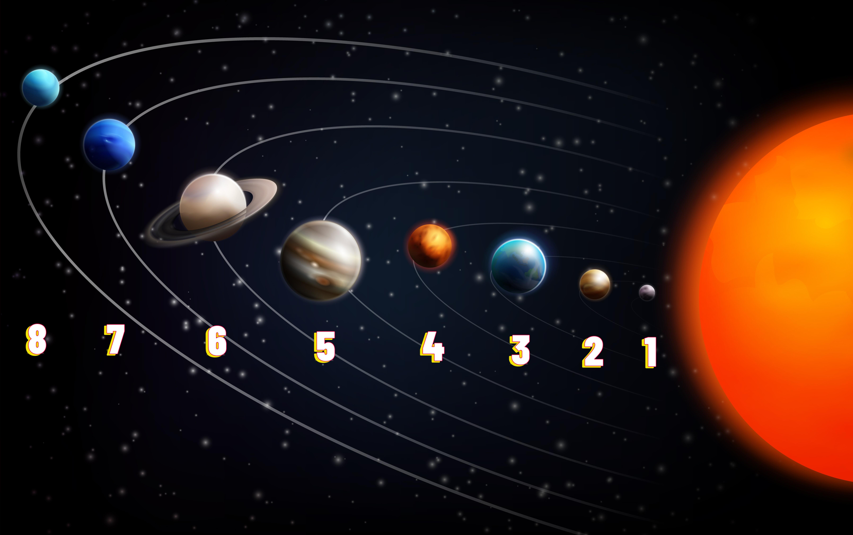

### Sort the planets from smallest to furthest distance to the Sun.

|  |  |  |
| --- | --- | --- |
| 1 |  | Neptune |
| 2 |  | Earth |
| 3 |  | Mars |
| 4 |  | Saturn |
| 5 |  | Jupiter |
| 6 |  | Uranus |
| 7 |  | Venus |
| 8 |  | Mercury |

|  |
| --- |
| A closer look at a planet Now learn more about a planet in our solar system. Read the text, then fill out the profile on the following page. |

# Jupiter

Jupiter is a giant planet that captures the interest of many people. It is the fifth planet from the Sun in our solar system and is the largest planet we know of. In fact, Jupiter is so big that more than 1,300 Earths could fit inside it! Its diameter is about 142,984 kilometers, making it a true giant among planets.

gas

liquid

hydrogen

helium

Jupiter is not a rocky planet like Earth. Instead, it is mostly made up of and . The planet's composition is primarily and , similar to the Sun. Deep inside Jupiter, there might be a small, rocky core, but it is surrounded by thick layers of gas and liquid.

Great Red Spot

The atmosphere of Jupiter is very interesting. It is full of swirling clouds and storms. One of the most famous features of Jupiter's atmosphere is the , which is a giant storm that has been raging for hundreds of years. The atmosphere is mostly made of hydrogen and helium, with traces of other gases like methane and ammonia.

Sun

In our solar system, Jupiter holds the position of the fifth planet from the . It is located between Mars and Saturn. Because of its large size and strong gravity, Jupiter plays an important role in the solar system by influencing the orbits of other objects.

moons

Io

Europa

Ganymede

Callisto

Galilean moons

Jupiter has many and a faint ring system. It has at least 79 known moons, with the four largest being , , , and . These are called the , named after the astronomer Galileo Galilei who discovered them in 1610. Jupiter's rings are not as noticeable as Saturn's, but they are still an important feature of the planet.

habitability

When it comes to , Jupiter is not a place where humans or other life forms could live. The planet does not have a solid surface, and its atmosphere is full of dangerous gases and extreme weather. However, some of its moons, like Europa, are of great interest to scientists because they might have conditions that could support life.

In summary, Jupiter is the largest planet in our solar system, made mostly of gas and liquid, with a thick atmosphere and many moons. While it is not habitable for humans, it remains a fascinating subject of study and exploration.

|  |  |
| --- | --- |
|  | Name |
| Size of the planet |
| Composition of the planet |
| Atmosphere | |
| Position in the solar system | |
| Satellites and rings | |
| Habitability | |

# Additional information for teachers

Here you can find a sample solution for the profile of the planet.

|  |  |
| --- | --- |
|  | Name  Jupiter |
| Size of the planet  Largest in the solar system, diameter of about 142,984 kilometers |
| Composition of the planet  Mostly gas and liquid, primarily hydrogen and helium, possible small rocky core |
| Atmosphere  Swirling clouds and storms, includes the Great Red Spot, mostly hydrogen and helium with traces of methane and ammonia | |
| Position in the solar system  Fifth planet from the Sun, located between Mars and Saturn | |
| Satellites and rings  At least 79 moons, four largest are Io, Europa, Ganymede, and Callisto (Galilean moons), faint ring system | |
| Habitability  Not habitable for humans, no solid surface, dangerous gases, extreme weather, some moons like Europa may have conditions that could support life | |

|  |
| --- |
| Mnemonic to remember the order of planets Here is a tip how you can remember the order of planets: in the following mnemonic each word starts with the same letter as one of the planets:      m  v  e  m  j  s  u  n  y ery ducated other ust erved s oodles      M  V  E  M  J  S  U  N  ercury enus arth ars upiter aturn ranus eptune |