# How do day &amp; night and the seasons occur?

Watch the following video:

|  |  |
| --- | --- |
|  | Youtube: Why Do We Have Different Seasons? | California Academy of Sciences  To watch the youtube video just scan the QR code.  https://www.youtube.com/watch?v=WgHmqv_-UbQ |

In your own words, summarize the connection between Earth's rotation and the change of seasons. Also, talk about its effect on vegetation.

___________________________________________________________________

___________________________________________________________________

___________________________________________________________________

Effects of Earth's rotation on Papua New Guinea

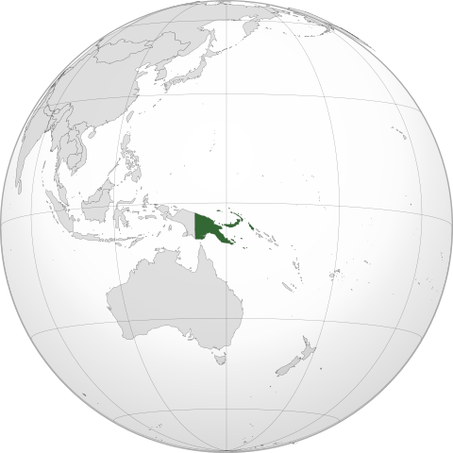

Wikipedia

Source:

The Earth's rotation plays a critical role in shaping the climate and seasons experienced in Papua New Guinea. As the Earth rotates on its axis, it influences the distribution of sunlight, creating day and night cycles that are fundamental to weather patterns and seasonal changes.

In Papua New Guinea, this rotation results in a tropical climate with little variation in daylight hours throughout the year. The country experiences around 12 hours of daylight daily due to its proximity to the equator. The temperatures are relatively stable, with coastal regions averaging between 25°C to 30°C throughout the year. The highland areas are cooler, averaging 15°C to 25°C.

The warmest months are typically November to April, coinciding with the wet season, where temperatures can reach up to 32°C. The coolest months, from May to October, align with the dry season, with temperatures occasionally dipping to around 20°C in the highlands.

The Earth's rotation also affects atmospheric circulation, contributing to the country's distinct wet and dry seasons. The wet season brings heavy rainfall and humidity, while the dry season is characterized by milder conditions and less precipitation. These seasonal changes are vital for the country's agriculture, affecting the growth cycles of crops and the availability of water resources.

One of the most exciting natural phenomena influenced by the Earth's rotation is a solar eclipse. Papua New Guinea will witness an annular solar eclipse on February 5, 2046. During this event, the moon will pass between the Earth and the sun, creating a "ring of fire" effect as the sun's outer edges remain visible.

In summary, the Earth's rotation not only defines the rhythm of day and night but also orchestrates the seasonal cycles and climatic variations that characterize the diverse landscapes of Papua New Guinea. The stable climate and predictable seasons support the country's rich biodiversity and vibrant ecosystems.

### For each statement, choose if it's true or false.

###### **Papua New Guinea experiences around 12 hours of daylight daily due to its proximity to the equator.**

True False

###### **The Earth's rotation has no impact on the climate of Papua New Guinea.**

True False

###### **The highland areas of Papua New Guinea experience average temperatures between 15°C to 25°C.**

True False

###### **The wet season in Papua New Guinea occurs from May to October.**

True False

###### **During the wet season, temperatures in Papua New Guinea can reach up to 32°C.**

True False

###### **Papua New Guinea will witness a total solar eclipse on February 5, 2046.**

True False

###### **The Earth's rotation contributes to the atmospheric circulation that creates distinct wet and dry seasons in Papua New Guinea.**

True False

###### **The coolest months in Papua New Guinea are from November to April.**

True False

|  |  |  |  |  |  |  |  |  |  |  |  |  |  |
| --- | --- | --- | --- | --- | --- | --- | --- | --- | --- | --- | --- | --- | --- |
|  |  |  |  |  |  | 3 |  |  |  |  |  |  |  |
|  |  |  | 2 |  |  |  |  |  |  |  |  |  |  |
|  | 6 |  |  |  |  |  |  |  |  | 5 |  |  |  |
|  |  |  |  |  |  |  |  |  |  |  |  |  |  |
|  |  |  |  |  | 1 |  |  |  |  |  |  |  |  |
|  |  |  |  |  | 7 |  |  |  |  |  |  |  |  |
|  |  |  |  |  |  |  |  |  |  |  |  |  |  |
|  |  |  |  |  |  |  |  |  |  |  |  |  |  |
|  |  |  |  |  |  |  |  |  |  |  |  |  |  |
|  |  |  |  |  |  |  |  |  |  |  |  |  |  |
| 4 |  |  |  |  |  |  |  |  |  |  |  |  |  |
|  |  |  |  |  |  |  |  |  |  |  |  |  |  |

Across

3 The effect created by the Earth's rotation, defining periods of light and darkness (8)

4 The geographical feature that results in cooler temperatures in some regions of Papua New Guinea (9)

6 The temperature range for coastal regions in Papua New Guinea, in degrees Celsius (10)

7 The natural phenomenon that influences atmospheric circulation in Papua New Guinea (8)

Down

1 The type of climate experienced in Papua New Guinea (8)

2 The season in Papua New Guinea from November to April (3)

3 The season in Papua New Guinea from May to October (3)

5 The event occurring on February 5, 2046, in Papua New Guinea (7)