|  |
| --- |
| Getting to know unboxing videos Watch at least one unboxing video on a platform such as YouTube. |

### Take notes about the procedure

___________________________________________________________________

___________________________________________________________________

___________________________________________________________________

___________________________________________________________________

### Sort the (typical) sequence of an unboxing video.

|  |  |
| --- | --- |
|  | And now what? Finally, the box is once again viewed as a whole. What is (un)usable, too much/too little, still desirable, exciting…? Is something being sent back? What do people think differently about? What will change? |
|  | What does it say there? If there is a cover letter or a note, it could now be taken out and read aloud. Include pauses, comments, and reactions! |
|  | What is in the box? Now the individual items are coming to light one after another. The recipient reacts with emotions, reactions, and comments. |
|  | Hello! The person unboxing introduces themselves. They provide information about the history or background of the unboxing video. |
|  | The first look! The recipient opens the box and describes what they discover in the box at first glance. He or she provides an initial overview of the contents and perhaps also of the packaging material. |
|  | What is that? Even before unpacking, something can be said about the packaging, the writing, and the presentation. Something can also be said about the sender and the delivery service. |

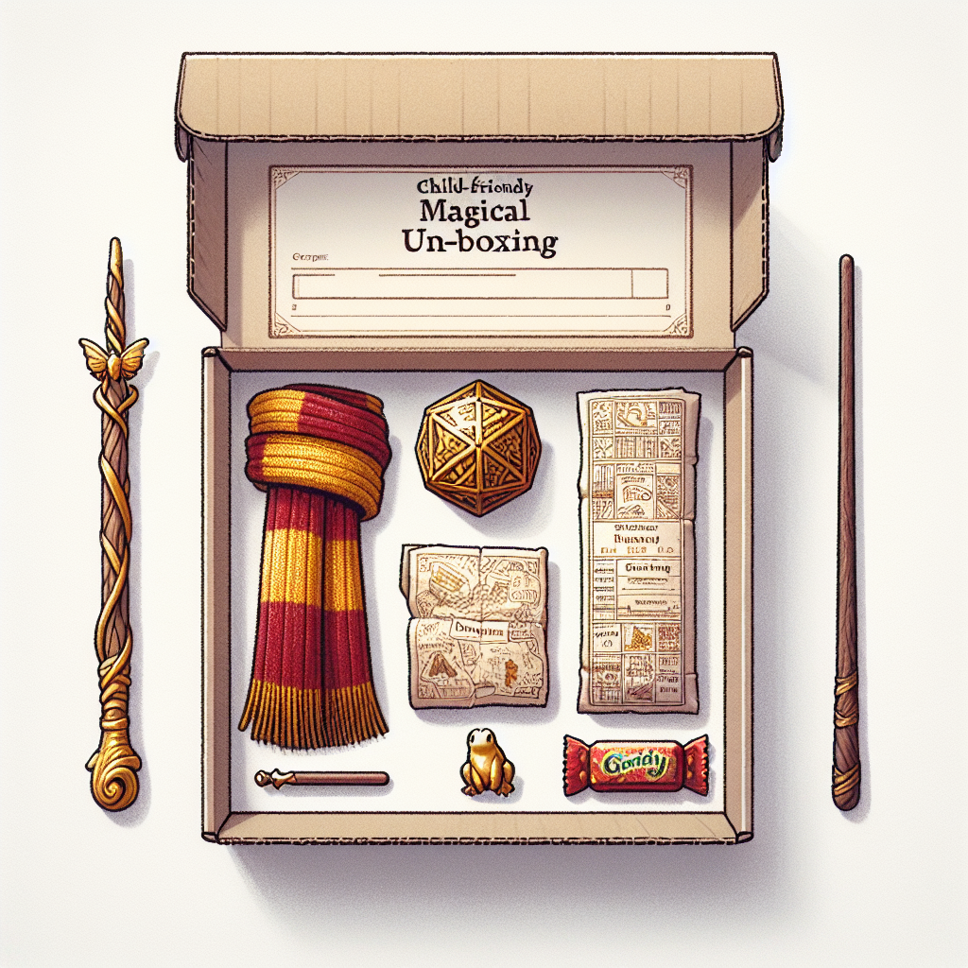

Which objects can you see?

___________________________________________________________________

___________________________________________________________________

___________________________________________________________________

Explain whether the selection of items is suitable for this person or not. What would you change or keep the same?

___________________________________________________________________

___________________________________________________________________

___________________________________________________________________

|  |
| --- |
| Preparing and packing the box Now you know how an unboxing video can be structured. Are you ready for your own unboxing?    First, the box needs to be filled.    Step 1:  Choose a literary character or an author to fill this box about.    Step 2:  What do you know about this person? What have you learned? Write down all your knowledge (initially) in an unsorted manner.    Step 3:  Consider who the recipient should be (e.g., your class, your parents, or a completely different person?).    Step 4:  What would the character or author write in a note included in the box? Consider the recipient.    Step 5:  Choose the possible appropriate items to go in the box. Why do you choose these items? |

### Space for your notes

Work through the steps: Choose your literary character, write down everything you know,…

___________________________________________________________________

___________________________________________________________________

___________________________________________________________________

___________________________________________________________________

|  |
| --- |
| Shoot your unboxing video tips regarding the technique:  Now slip into the role of the recipient. Pay attention to the instructions for the process that you have already organized (see above). Here are a few more    lighting  What kind of would enhance the mood (bright, dark, spotlight)?  without interruptions  Where can the video be recorded ?  music  Is there background ? If so, be mindful of copyright.  recording device  What will be used? And from what perspective?  microphone  Which ?  editing  Which app can be used for ? |