Info
In this worksheet, you will get to know an important historical figure. You will find out who this person was, what era they lived in and what influence they had on history. Let yourself be surprised by exciting facts and interesting stories as you learn more about this fascinating figure and his time. Have fun discovering!

📋 Assignment

Read the text and then complete the profile.

Queen Elizabeth II (1926–2022)

Queen Elizabeth II, born Elizabeth Alexandra Mary Windsor on April 21, 1926, in Mayfair, London, was the longest-reigning British monarch. She ascended the throne on February 6, 1952, following the death of her father, King George VI, and reigned until her death on September 8, 2022.

Elizabeth's early life was shaped by the abdication crisis of 1936, which saw her father become king and her becoming the heir presumptive. She was home-schooled and undertook public duties during World War II, serving in the Auxiliary Territorial Service.

In 1947, Elizabeth married Philip Mountbatten, a former prince of Greece and Denmark. Their marriage lasted 73 years, producing four children: Charles, Anne, Andrew, and Edward. Elizabeth was crowned in 1953, marking the beginning of a reign that saw significant political changes, including the decolonization of Africa and the Caribbean, and the UK's joining and leaving the European Union.

Her reign, spanning 70 years, was marked by major events such as her Silver, Golden, Diamond, and Platinum jubilees. Despite facing challenges, including family scandals and criticisms, she maintained high public approval. Elizabeth met numerous world leaders, including five popes and fourteen US presidents, symbolizing her global influence.

Elizabeth's legacy includes her dedication to her role and her ability to adapt to changing times while maintaining the monarchy's stability. She passed away at Balmoral Castle at the age of 96, succeeded by her eldest son, Charles III. Her life and reign remain a significant chapter in British history.

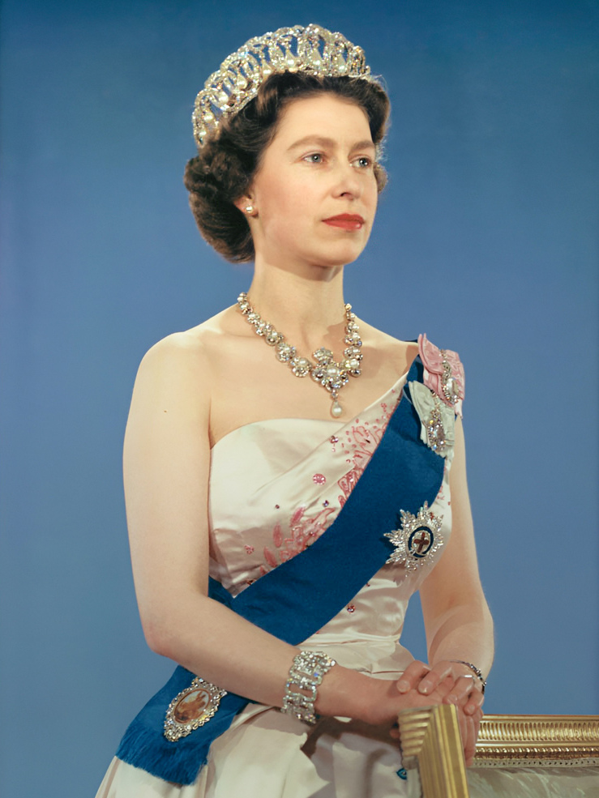 | Name  Queen Elizabeth II
Born
April 21, 1926
Place of birth
Mayfair, London
Life
Queen Elizabeth II was the daughter of King George VI. She became queen on February 6, 1952, after her father died. She was married to Philip Mountbatten for 73 years and had four children: Charles, Anne, Andrew, and Edward.
Work
During World War II, she served in the Auxiliary Territorial Service. As queen, she saw many political changes, including the decolonization of Africa and the Caribbean, and the UK's joining and leaving the European Union.
Achievement
Queen Elizabeth II reigned for 70 years and celebrated her Silver, Golden, Diamond, and Platinum jubilees. She met many world leaders, including five popes and fourteen US presidents.
Famous for
She was the longest-reigning British monarch and is known for her dedication to her role and ability to keep the monarchy stable through changing times.

Name

Born

Place of birth

Life

Work

Achievement

Famous for

📋 Answer the questions with the help of the text.

Why did Elizabeth become the heir presumptive in 1936?
She was the only child of King George VI. She was the eldest child of King George VI. Her father became king after the abdication crisis. Her mother abdicated the throne.

What significant global event did Elizabeth participate in during World War II?
She was a diplomatic envoy. She was a combat nurse. She served in the Auxiliary Territorial Service. She fought on the front lines.

Which major political change occurred during Elizabeth's reign?
The end of apartheid in South Africa. The UK's joining and leaving the European Union. The unification of Germany. The collapse of the Soviet Union.

What is one reason Queen Elizabeth II maintained high public approval despite challenges?
Her frequent travels to foreign countries. Her involvement in daily political decisions. Her public speeches and appearances. Her dedication to her role and ability to adapt to changing times.

Who succeeded Queen Elizabeth II after her death?
Prince Andrew Prince Philip Charles III Prince Edward

What was one of the major events celebrated during Elizabeth's reign?
Her 50th Wedding Anniversary Her Centenary Celebration Her Coronation Anniversary Her Platinum Jubilee

📋 For the quick ones

If you've already finished, you can still solve the puzzle! Fill in the correct words. If you are unsure, read the text again.
 |  | 2 |  |  |  |  | 1
 |  |  |  |  | 4
3

Across
3 Castle where Queen Elizabeth II passed away (8)

Down
1 Country where Queen Elizabeth II was born (7)
2 Queen Elizabeth II's husband (6)
4 World conflict during which Elizabeth undertook public duties (3)

