Definition of Social Movements

Social movements are organized efforts by a large group of people to achieve a common goal, typically to bring about or resist social, political, or economic change.

Example:
The Women's Suffrage Movement in the UK was a social movement aimed at securing women's right to vote.

Report on the Women's Suffrage Movement in 19th-20th Century UK

Introduction

The Women's Suffrage Movement in the United Kingdom was a pivotal socio-political movement aimed at securing women's right to vote. This movement spanned from the late 19th century into the early 20th century and culminated in legislative successes in 1918 and 1928.

Political Context

Initially, women were not explicitly banned from voting until the Reform Act of 1832 and the Municipal Corporations Act of 1835. The suffrage movement gained momentum in the Victorian era, with significant progress marked by the formation of key organizations such as the National Union of Women's Suffrage Societies (NUWSS) in 1897. Political resistance was significant, particularly from the ruling Liberal Party and figures like Prime Minister H. H. Asquith.

Social Context

Socially, the movement was part of a broader feminist agenda that included rights to property, education, and legal autonomy. Early suffragists like John Stuart Mill advocated for women's rights in the mid-19th century, leading to the formation of suffragist societies. The movement was characterized by both peaceful advocacy and militant actions, particularly from the Women's Social and Political Union (WSPU) founded by Emmeline Pankhurst in 1903.

Economic Context

Economically, the Industrial Revolution had resulted in increased employment opportunities for women, particularly in textiles and factories, which highlighted the disparities in political rights. The contribution of women to the workforce during World War I further underscored their capabilities and bolstered the argument for suffrage.

Key Events and Legislation

Formation of Suffrage Societies (1860s-1890s)
: The NUWSS and WSPU were formed, advocating for women's voting rights through both peaceful and militant means.

World War I (1914-1918)
: The war effort saw women taking on roles traditionally held by men, shifting public opinion in favor of women's suffrage.

Representation of the People Act 1918
: Enfranchised women over 30 who met minimum property qualifications, adding 8.4 million women to the electorate.

Representation of the People (Equal Franchise) Act 1928
: Granted equal voting rights to all men and women over the age of 21.

Conclusion

The Women's Suffrage Movement in the UK was a complex interplay of political lobbying, social activism, and economic necessity that eventually led to the enfranchisement of women. The success of the movement was marked by significant legislative changes in 1918 and 1928, fundamentally altering the political landscape of the country.

Voices of reform
Emmeline Pankhurst  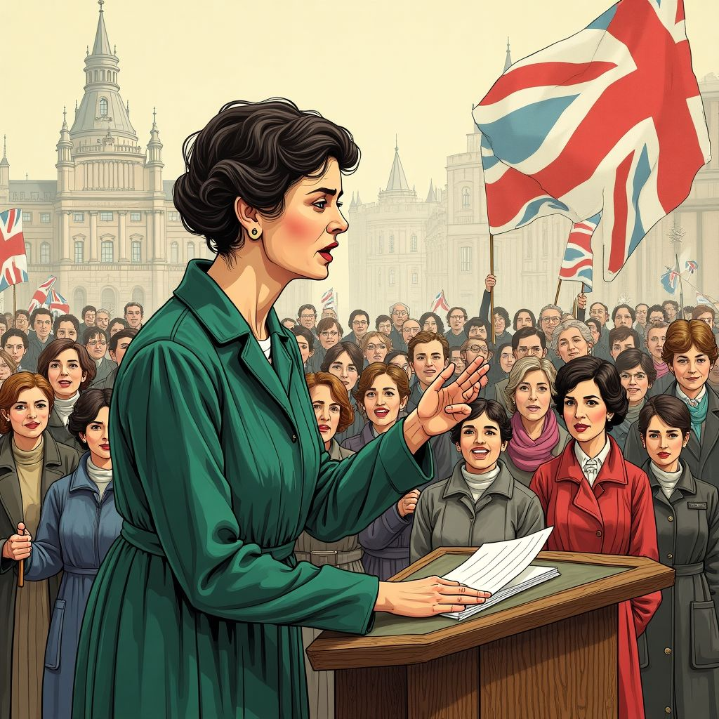  Role: Leader of the Women's Social and Political Union (WSPU) and a prominent suffragette.  Activities:  - Organize and lead protests and rallies demanding women's right to vote.  - Engage in militant tactics, including hunger strikes and property damage, to draw attention to the suffrage cause.  - Advocate for women's participation in the war effort during World War I.  - Transform the WSPU into the Women's Party post-war to promote women's equality in public life.  Emmeline Pankhurst was a fierce and determined activist whose militant approach played a crucial role in securing women's suffrage in the UK. | Millicent Fawcett  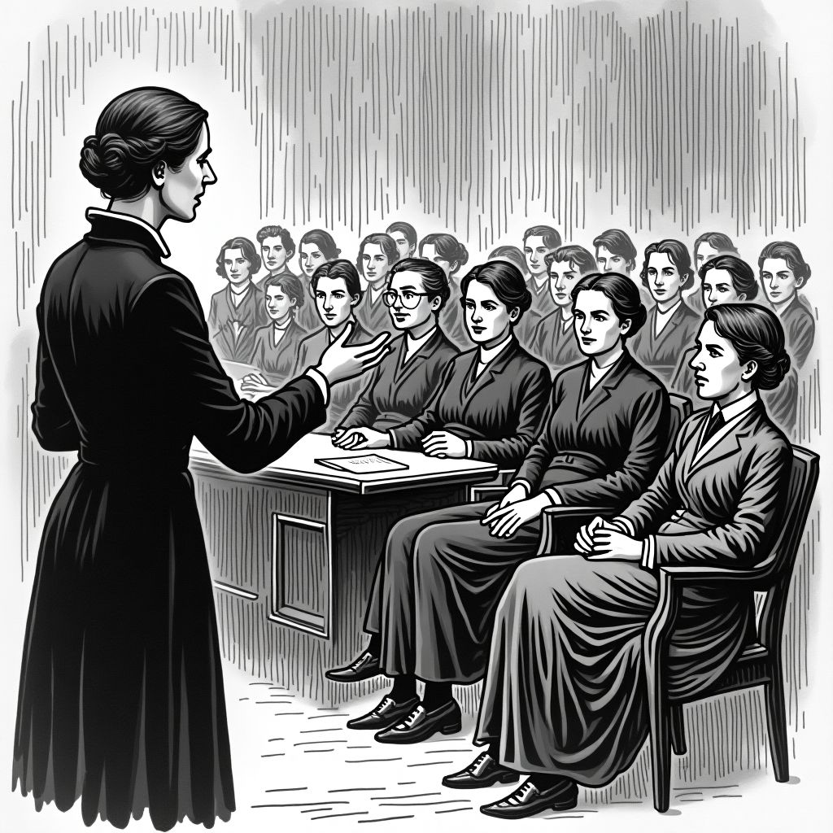  Role: Leader of the National Union of Women's Suffrage Societies (NUWSS) and a moderate suffragist.  Activities:  - Lead peaceful campaigns and lobbying efforts to gain women's right to vote through legal change.  - Advocate for women's higher education, co-founding Newnham College, Cambridge.  - Oppose militant suffrage tactics and maintain a law-abiding approach.  - Work on social issues such as child marriage, women's rights in the workplace, and the repeal of the Contagious Diseases Acts.  Millicent Fawcett was a dedicated and strategic leader who championed women's suffrage through peaceful and lawful means.

Be the voice

Prepare a short monologue that captures the motivations, challenges, and vision of Emmeline Pankhurst. Highlight her role in the suffrage movement, the strategies she employed, and her vision for women's rights.

___________________________________________________________________

___________________________________________________________________

___________________________________________________________________

___________________________________________________________________

After the movement
 | Audio Content  To listen to audio content just scan the QR code and listen to it on the digital worksheet.  https://to-teach.ai/worksheet/MQr54RBZFHBD9H54jkux

Evaluate the political rights and representation of women in the UK before and after the Women's Suffrage Movement.
___________________________________________________________________
___________________________________________________________________
___________________________________________________________________
Debate the social and economic impact of the Women's Suffrage Movement on contemporary UK society.
___________________________________________________________________
___________________________________________________________________
___________________________________________________________________

