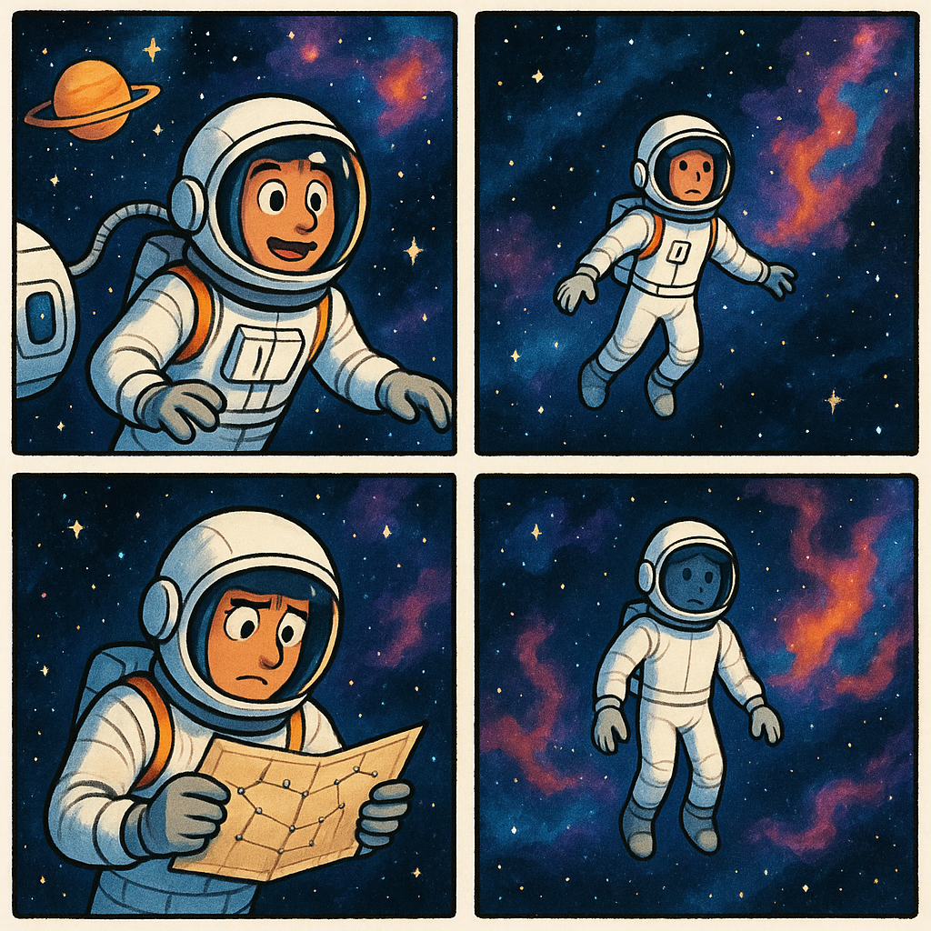

|  |
| --- |
| How do I analyze a comic strip? Part IFirst Impression   Start by noting your initial reaction:    What is your immediate emotional response?  What stands out to you visually?  What is your first interpretation of the message?   Visual Elements Examine the artistic choices:  Art Style: Realistic, cartoonish, minimalist?  Color Palette: Vivid, muted, black-and-white?  Panel Layout: Traditional grid or experimental?  Character Design: Exaggerated features, symbolism in appearance?  Use of Space: Overloaded, sparse, balanced? |

### Your notes

___________________________________________________________________

___________________________________________________________________

___________________________________________________________________

___________________________________________________________________

|  |
| --- |
| How do I analyze a comic strip? Part IINarrative Structure   Consider how the story unfolds:    Plot: Is there a clear beginning, middle, and end?  Pacing: How do the panels control the rhythm of the story?  Passage of Time: How is time represented between the panels?   Symbolism and Metaphors Look for deeper meanings:  Visual Metaphors: Are there objects or scenes that represent abstract concepts?  Recurring Symbols: Are certain images or motifs repeated?  Cultural References: Are there allusions to current events or pop culture? Tone and Mood Assess the overall feeling:  Is it humorous, satirical, dramatic, or melancholic?  How do the visual and textual elements contribute to this tone? |

### Your notes

___________________________________________________________________

___________________________________________________________________

___________________________________________________________________

___________________________________________________________________

|  |
| --- |
| How do I analyze a comic strip? Part IIICharacter Analysis   Examine the portrayed personalities:    Character Development: Static or dynamic?  Relationships: How do the characters interact?  Stereotypes: Are they used? Subverted?   Social Context Place the comic in a broader context:  When was it created? How does it reflect its time?  What social, political, or cultural themes does it address?  Who is the target audience? |

### Your notes

___________________________________________________________________

___________________________________________________________________

___________________________________________________________________

___________________________________________________________________

### Analyze the Comic Strip

___________________________________________________________________

___________________________________________________________________

___________________________________________________________________

___________________________________________________________________

Explain how the visual elements in the background enhance the emotional journey of the astronaut through the panels.

___________________________________________________________________

___________________________________________________________________

___________________________________________________________________

Describe the significance of the astronaut's decision to consult the star map in Panel 3 and how it reflects human resilience.

___________________________________________________________________

___________________________________________________________________

___________________________________________________________________

Name a theme depicted in the comic strip and explain how the progression of the astronaut's emotions supports this theme.

___________________________________________________________________

___________________________________________________________________

___________________________________________________________________