### Activity 1 - who are you?

Alone or in groups, collect as many ideas as you can on the question of what constitutes your identity. What makes you you?

___________________________________________________________________

___________________________________________________________________

___________________________________________________________________

___________________________________________________________________

## Different aspects of identity

Before exploring one aspect of identity in more detail, look at the different kinds of identity shown in the mind map. Is there anything missing in your opinion?

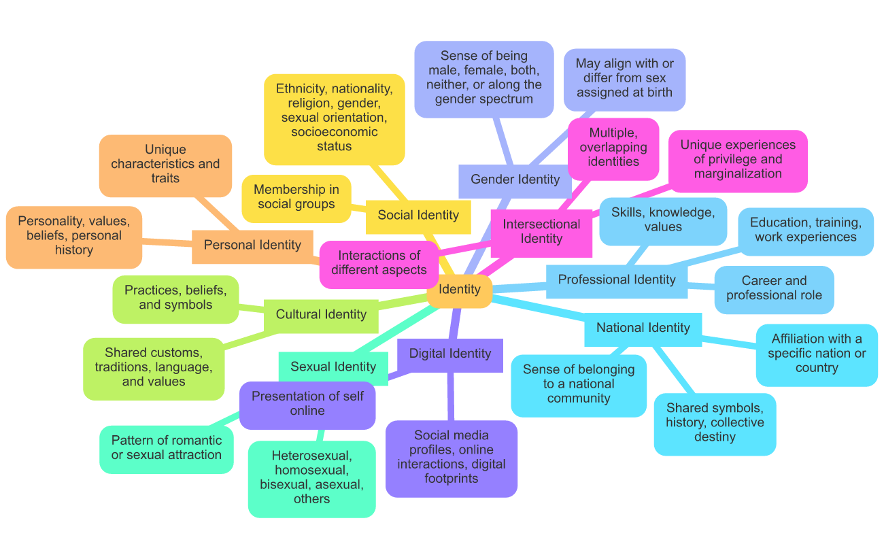

### Understanding Personal Identity

At the core of our being is the fundamental question of "Who am I?". This search for personal identity is a lifelong journey, as we work to understand ourselves and our place in the world. From a scientific perspective, our personal identity is shaped by a complex interplay of biological, psychological, and social factors.

At the biological level, our genes and brain chemistry play a significant role in shaping our personality, temperament, and cognitive abilities. Researchers have found that certain genetic variations are associated with traits like extroversion, neuroticism, and risk-taking behavior. The brain also has a profound influence on identity, with different regions responsible for various aspects of the self, such as self-awareness, decision-making, and emotional regulation.

Beyond the biological factors, our psychological development also shapes our personal identity. We engage in a process of self-exploration, questioning, and experimentation as we work to establish a coherent sense of who we are. Our hobbies, interests, and values are all integral parts of this identity formation.

The social context in which we grow up also has a significant impact on our identity. The people, cultures, and institutions we interact with all contribute to the formation of our self-concept. Our family, friends, and community provide us with feedback, expectations, and role models that influence how we see ourselves and the world around us.

Our personal values, beliefs, and moral principles are also key components of our identity. These shape our decision-making, our relationships, and our overall worldview. Whether it's a deep commitment to environmental sustainability, a passion for the arts, or a strong sense of social justice, our values are a fundamental part of who we are.

It's important to note that personal identity is not a fixed or static concept. Rather, it is a dynamic and evolving process that continues throughout our lives. As we encounter new experiences, relationships, and challenges, our sense of self will continue to shift and develop.

### Answer the questions about the text

###### **Which factors primarily shape our personal identity from a biological perspective?**

Our hobbies and interests Genes and brain chemistry Our family and community Cultural expectations

###### **Why is the brain significant in the formation of personal identity?**

It dictates our hobbies and interests It is responsible for self-awareness and emotional regulation It alone determines our values and beliefs It provides feedback from family and friends

###### **How do social contexts influence our personal identity?**

Through self-awareness and emotional regulation By providing us with genetic variations By determining our brain chemistry Through feedback, expectations, and role models

###### **What role do personal values and beliefs play in shaping identity?**

They do not influence relationships They shape our decision-making and worldview They are irrelevant to personal identity They are solely determined by our genetic makeup

###### **How does personal identity evolve over time?**

It changes only during childhood It evolves through new experiences and challenges It is fixed after adolescence It remains static and unchanging

###### **What aspect of the brain is involved in decision-making and self-awareness?**

The occipital lobes The limbic system The frontal lobes The parietal lobes

###### **Which of the following is NOT a factor in shaping personal identity?**

Genetic makeup Cultural and social interactions Brain regions involved in self-awareness Economic inflation

###### **In which way can family and community impact a person's identity?**

By defining personal hobbies By altering their genetic code By providing role models and expectations By directly controlling brain chemistry

## Explore identity

These questions are supposed to help you understand the concepts better by asking yourself some personal questions. You do not have to share your answers with anyone. This is your space.

What are your core values and beliefs, and how do they shape your decisions and actions?

___________________________________________________________________

___________________________________________________________________

___________________________________________________________________

Describe your unique personality traits, strengths, and weaknesses. How do these contribute to your sense of self?

___________________________________________________________________

___________________________________________________________________

___________________________________________________________________

What are your passions, hobbies, and interests? How do these activities and pursuits reflect who you are?

___________________________________________________________________

___________________________________________________________________

___________________________________________________________________

How have your family, cultural background, and upbringing influenced the way you see the world and your place in it?

___________________________________________________________________

___________________________________________________________________

___________________________________________________________________

Describe a significant life experience or challenge that has had a profound impact on your identity and personal growth.

___________________________________________________________________

___________________________________________________________________

___________________________________________________________________

If you could change one thing about yourself, what would it be, and why? How would that change affect your sense of identity?

___________________________________________________________________

___________________________________________________________________

___________________________________________________________________

How do you think your identity will continue to evolve and change over time as you encounter new experiences and relationships?

___________________________________________________________________

___________________________________________________________________

___________________________________________________________________

### Assignment

Create a collage that visually represents your core values and beliefs.

## What influences us?

Read the chat conversation

Conversation on Personal Identity

Hey Jamie, have you ever thought about how role models and stereotypes influence our sense of identity?

Yeah, I think about that a lot. Role models definitely have a big impact on how we see ourselves. They can inspire us to pursue certain goals or adopt specific values.

For sure. I feel like having positive role models can really help shape our personal values and aspirations. But what about stereotypes and labels? How do you think they affect our identity?

Stereotypes and labels can be really limiting. They often put people in boxes and make it hard for them to express their true selves. It can be tough to break free from those expectations.

Yeah, I agree. It's like they create these invisible boundaries that can restrict our personal growth. Have you ever felt pressured to conform to a certain stereotype?

Definitely. Sometimes I feel like I have to act a certain way to fit in with my friends or to meet the expectations of my family. It can be exhausting.

I know what you mean. It's challenging to balance being true to yourself while also trying to meet others' expectations. How do you think we can break free from these stereotypes?

I think it starts with self-awareness and being confident in who we are. Surrounding ourselves with supportive people who accept us for who we are also helps. And sometimes, we just need to challenge those stereotypes directly.

That's a good point. Building a strong sense of self and having a supportive community can make a big difference. Do you have any role models that have helped you with this?

Yeah, my older sister has been a huge influence. She's always been true to herself and encourages me to do the same. It really helps to have someone like that to look up to.

### Write a personal response to the chat, explaining your own opinion.

___________________________________________________________________

___________________________________________________________________

___________________________________________________________________

___________________________________________________________________