📌 Info
In this worksheet, you will look at the role of women in a historical context. You will learn about the circumstances of women's lives and gain an insight into the lives, successes and challenges of two well-known women.
Letter to my cousin
✉️

December 1, 1919

Dear Anna,

I hope this letter finds you well. Life here in Germany has been quite tumultuous lately, but also full of hope and change. You may have heard about the German Revolution of 1918-1919. It all started with a mutiny by sailors in Kiel, which quickly spread across the country. By November 9, 1918, the German Empire had fallen, and we were declared a republic. This revolution brought about the Weimar Republic, which promises many changes, especially for us women.

One of the most exciting developments is that women now have the right to vote! This was something unimaginable just a few years ago. My mother and aunts are thrilled and have been discussing politics at every family gathering. They believe that our voices can now be heard, and this gives me hope for our future.

However, not everything is perfect. Many of our older female relatives are cautious. My grandmother, for instance, worries that these changes might not last. She often talks about the hardships during the war and fears that the new government might face the same fate as the old one if it doesn’t address the people’s needs.

The Council of the People's Deputies, which took over after the revolution, made significant promises like freedom of expression and an eight-hour workday. Yet, there are still many challenges. The country is divided, with some supporting the new republic and others longing for the past. The economic situation is tough, and there’s a lot of unrest.

Despite the uncertainties, I feel a sense of empowerment. Being 14 in this new Germany means growing up with more opportunities and rights than our mothers and grandmothers had. I hope that by the time we are adults, these changes will have taken firm root, and we can live in a truly equal society.

Write back soon and tell me how things are in your part of the world.

With love,
Liesel

📋 Work order

Answer the questions with the help of the text.

How does Elise perceive the current role of women?
___________________________________________________________________
___________________________________________________________________
___________________________________________________________________
Are there signs of changes in the circumstances for women in the future?
___________________________________________________________________
___________________________________________________________________
___________________________________________________________________

📋 Work order

important aspects
successes
challenges
their role in history
Read through the stories of the two women and highlight of their lives, , and .
Clara Zetkin  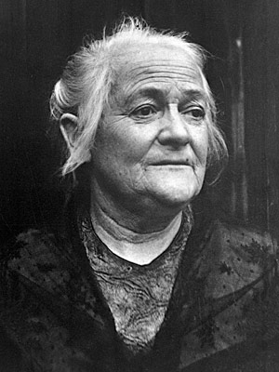  I am Clara Zetkin, born on July 5, 1857, in Wiederau, Kingdom of Saxony. Throughout my life, I devoted myself to the fight for women's rights, socialism, and peace. As a politician and activist, I faced numerous challenges in a society that restricted women's roles to the household. Despite these obstacles, I persevered, advocating for women's suffrage, equal education, and labor rights. One of my significant successes was organizing the first International Women's Day in 1911. Even though I encountered resistance and societal norms, my work laid the groundwork for future generations of women to enjoy greater freedoms and equality. My legacy continues to inspire those who strive for social justice and gender equality.  Clara Zetkin was a pioneering women's rights activist and socialist who played a crucial role in organizing the first International Women's Day. Her advocacy for women's suffrage, education, and labor rights laid the foundation for future advancements in gender equality. | Rosa Luxemburg  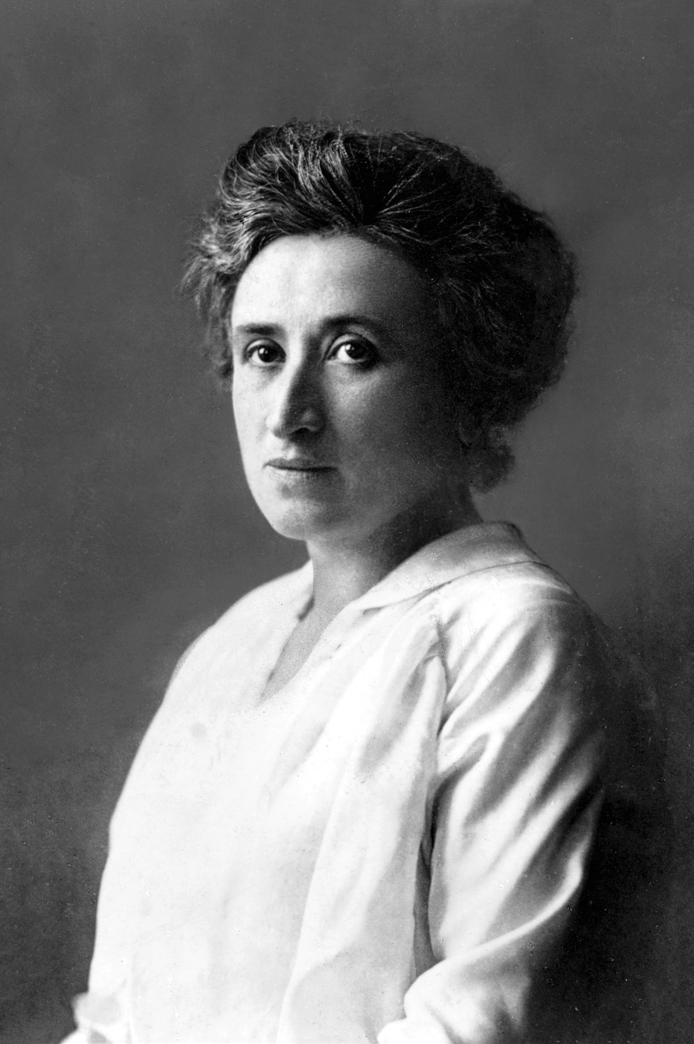  I am Rosa Luxemburg, born on March 5, 1871, in Zamość, Congress Poland. As an economist, revolutionary, and political theorist, I dedicated my life to the struggle for social justice and equality. My journey was fraught with challenges, especially as a woman in a male-dominated political arena. I co-founded the Spartacus League and the Communist Party of Germany, advocating for workers' rights and opposing militarism. Despite being imprisoned and ultimately executed for my beliefs, I left a lasting impact through my writings and revolutionary activities. My work continues to inspire those who fight for social and economic justice worldwide.  Rosa Luxemburg was a revolutionary socialist and political theorist whose advocacy for workers' rights and opposition to militarism left a lasting legacy. Her contributions to political thought and her role in founding the Communist Party of Germany continue to influence movements for social justice.

Familiarize yourself with the lives and contributions of Clara Zetkin and Rosa Luxemburg. Evaluate their impact on women's rights, socialism, and social justice movements.
Life data
Include key dates, places, and major events in their lives. Mention their early life, education, and any significant personal experiences that shaped their paths.
Successes
Discuss their major achievements and contributions. Highlight key successes such as organizing the first International Women's Day or founding political organizations.
Challenges
Describe the obstacles and challenges they faced. Consider societal norms, political opposition, and personal hardships.
Role in history
Analyze their overall impact on history. Discuss how their work influenced future generations and movements for social justice and gender equality.

