## Bavaria

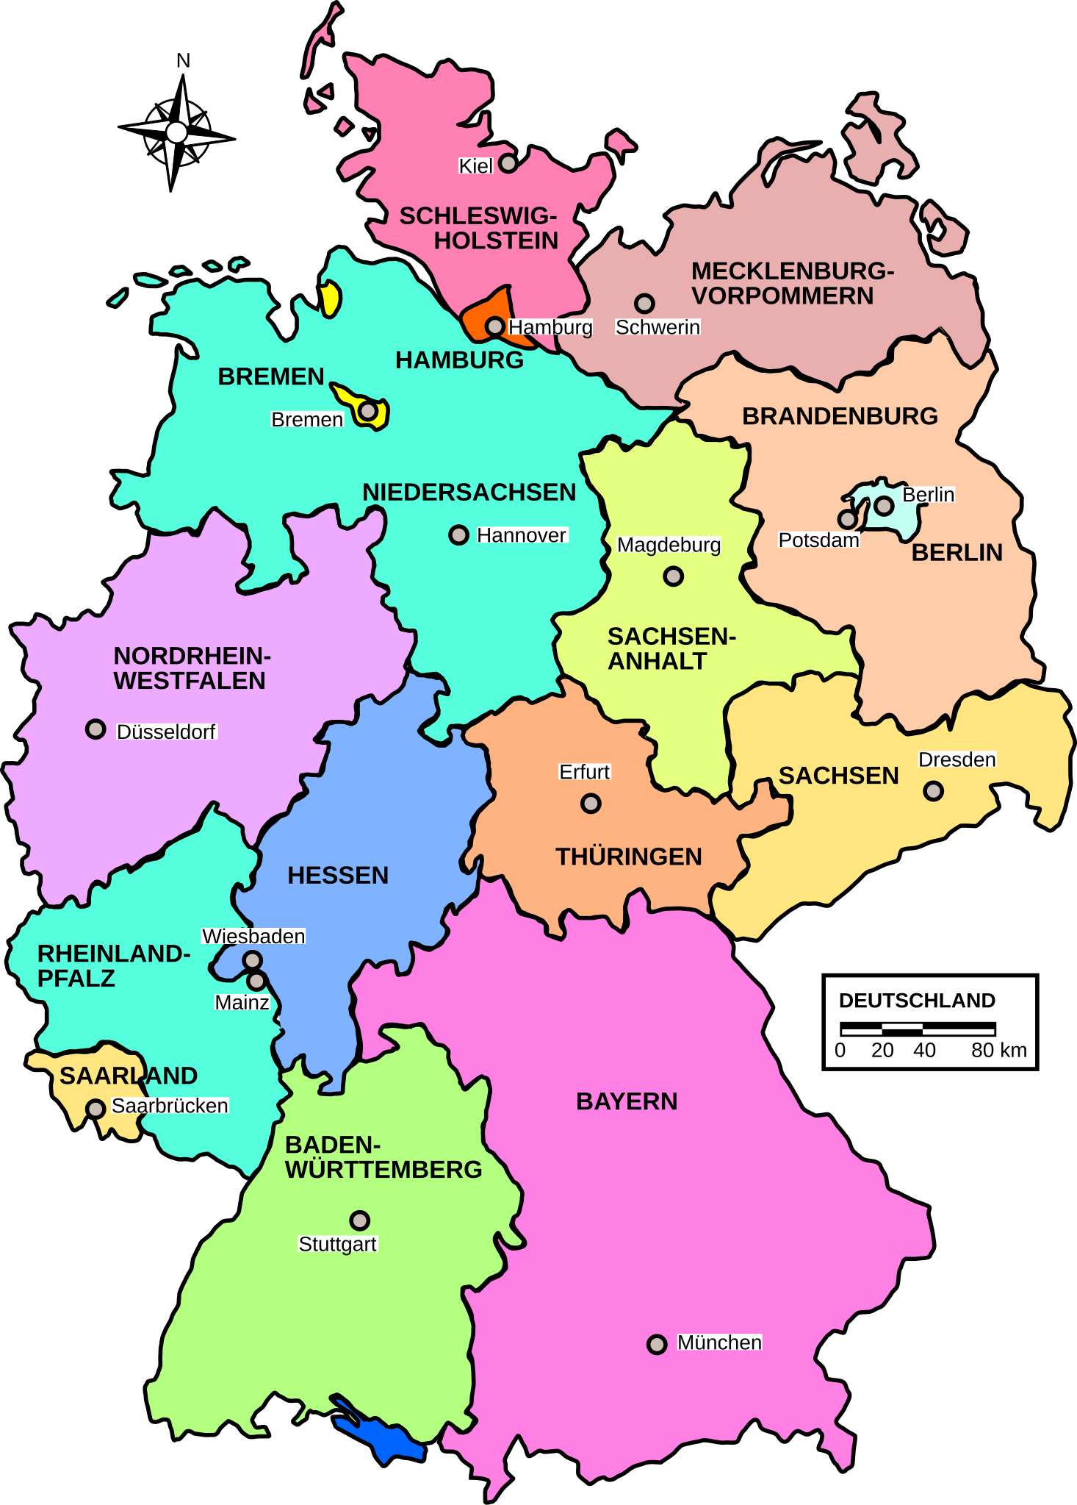

Source: Wikipedia

Bavaria, officially the Free State of Bavaria, is a state in southeast Germany. It is the largest German state by land area, covering 70,550.19 km², and has a population of over 13 million people. Its capital and largest city is Munich, which is also Germany's third-largest city.

Bavaria is known for its diverse geography, featuring the Alps, large forests, and rivers such as the Danube and Main. The state borders Austria, the Czech Republic, and Switzerland, as well as the German states of Baden-Württemberg, Hesse, Thuringia, and Saxony.

Politically, Bavaria is predominantly governed by the conservative Christian Social Union (CSU). Markus Söder from the CSU is the current Minister-President, and the Free Voters party also plays a significant role in the state government.

Bavaria has a unique culture, influenced by its Catholic heritage. Traditional Bavarian attire includes Lederhosen for men and Dirndls for women, commonly worn during festivals like Oktoberfest, the world’s largest beer festival. The state is also famous for its hearty cuisine, including dishes like Weisswurst (white sausage) and pretzels.

Nature lovers can enjoy Bavaria’s numerous mountains, lakes, and forests. The Bavarian Forest and the Alps are popular destinations for hiking and skiing. The state also boasts many historic sights, such as Neuschwanstein Castle, often called the "fairytale castle," and the medieval town of Rothenburg ob der Tauber.

Bavaria's economy is one of the strongest in Germany, with major industries including automotive, engineering, and information technology. Notable companies like BMW, Audi, and Siemens are headquartered here.

Bavaria’s combination of rich cultural traditions, natural beauty, and economic strength makes it a fascinating state to explore and learn about.

## Characteristics

Complete the profile with information from the text.

|  |  |
| --- | --- |
|  | Population |
| Size in km² |
| Capital |
| Geography | |
| Political parties in power | |
| Culture & Sights | |
| Nature | |

### In every sentence there is at least one piece of wrong information. Mark it and write the correct solutions underneath.

1. Bavaria, officially the Free State of Bavaria, is the smallest German state by land area, covering 70,550.19 km².  
2. Its capital and largest city is Hamburg, which is also Germany's third-largest city.  
3. The state borders Austria, the Czech Republic, and Italy, as well as the German states of Baden-Württemberg, Hesse, Thuringia, and Saxony.  
4. Politically, Bavaria is predominantly governed by the conservative Christian Social Union (CSU). Angela Merkel from the CSU is the current Minister-President, and the Free Voters party also plays a significant role in the state government.  
5. Traditional Bavarian attire includes Lederhosen for men and Dirndls for women, commonly worn during festivals like Christmas Market, the world’s largest beer festival.  
6. Nature lovers can enjoy Bavaria’s numerous mountains, lakes, and forests. The Bavarian Forest and the Rhine Valley are popular destinations for hiking and skiing.  
7. The state also boasts many historic sights, such as Heidelberg Castle, often called the "fairytale castle," and the medieval town of Rothenburg ob der Tauber.  
8. Bavaria's economy is one of the strongest in Germany, with major industries including automotive, engineering, and agriculture.

### Corrected sentences

Use this space to write down the corrected sentences.

___________________________________________________________________

___________________________________________________________________

___________________________________________________________________

___________________________________________________________________