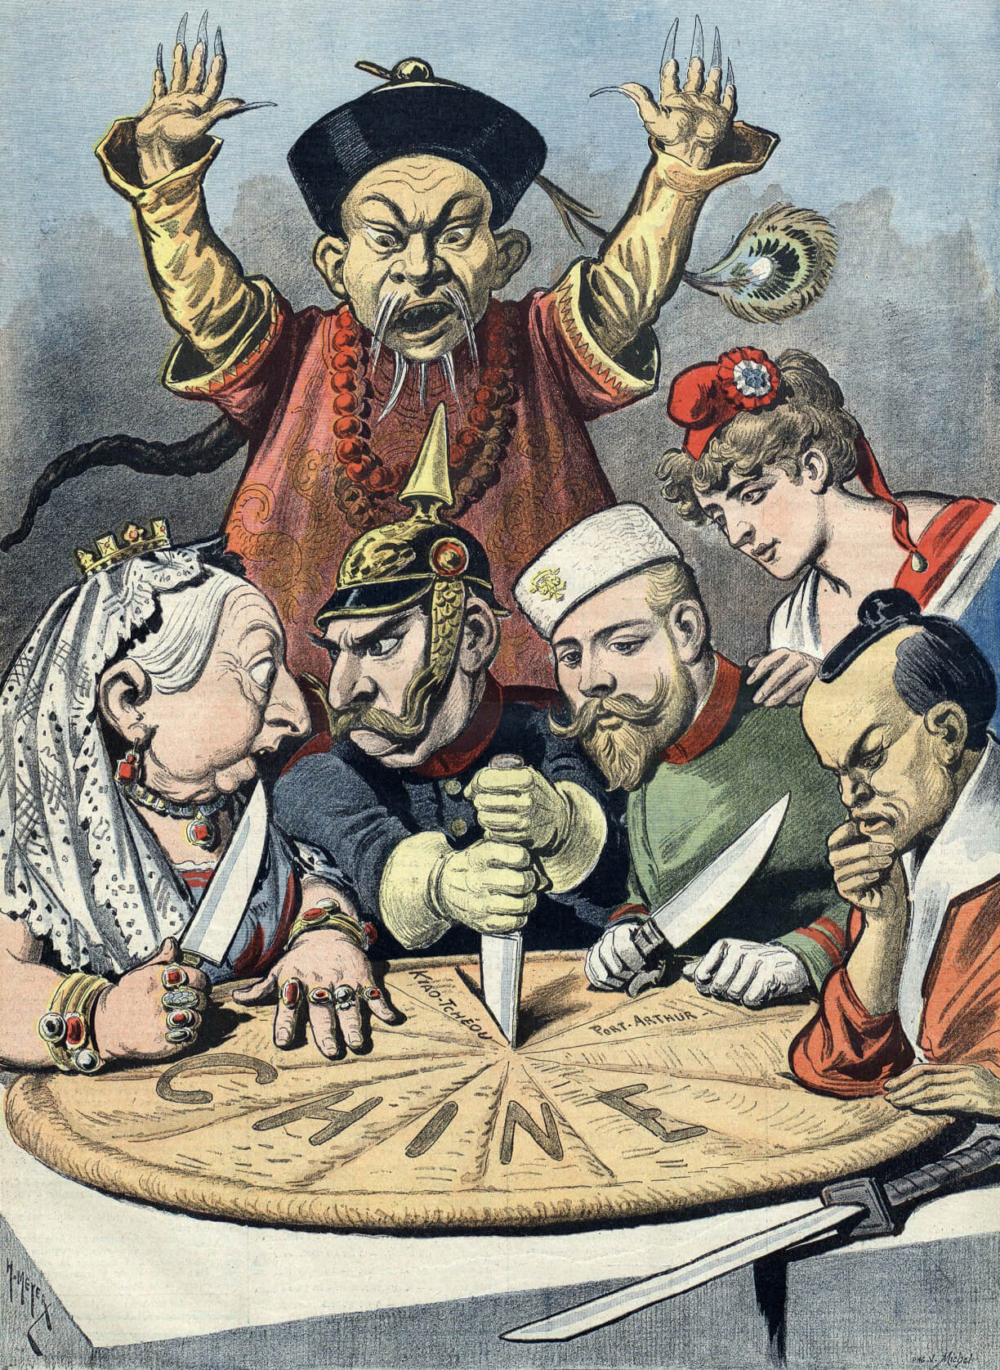
"En Chine Le gâteau des Rois et... des Empereurs" - Henri Meyer - "Le petit journal" - 16.01.1898

Choose the correct answer

The main topic of the cartoon is the division of China's land and resources by foreign powers.
True False

The cartoon was published in 'Le petit journal' on January 16, 1898.
True False

Henri Meyer created this cartoon for 'Le petit journal'.
True False

The cartoon shows various national powers represented by figures in different attire and insignia.
True False

The pie in the cartoon is labeled 'Chine', which means China in French.
True False

One of the figures representing national powers is wearing a distinctive German military helmet called a Pickelhaube.
True False

The figure representing China in the cartoon is wearing a crown.
True False

The place names written on the pie/map in the cartoon do not include 'Port Arthur'.
True False

Analyzing political cartoons
First, take a close look at the different parts of the cartoon. Notice the people, animals, objects, and other details you can see. Pay attention to the facial expressions and body language of the characters. Don't forget to include any text in the cartoon, like speech bubbles or captions.

Next, it's time to understand the cartoon in its historical context. Gather extra information like the title of the cartoon, the name of the artist, where and when it was created and published, and what the cartoon is about.

Describe the attire and insignia of the figures surrounding the pie in the cartoon. What do they signify?
___________________________________________________________________
___________________________________________________________________
___________________________________________________________________
Explain the significance of the Chinese figure's expression and position in the cartoon.
___________________________________________________________________
___________________________________________________________________
___________________________________________________________________

