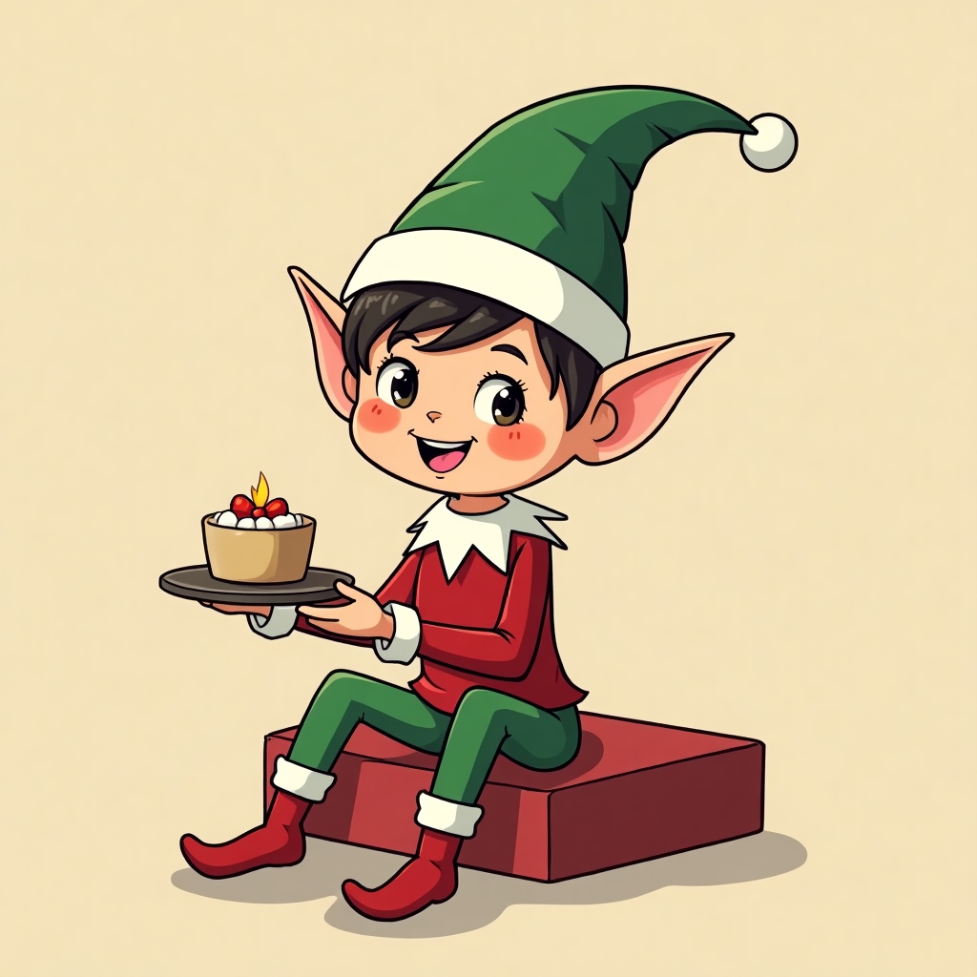

### Elf on the Shelf: A Beloved Christmas Tradition

Elf on the Shelf

The is a 2005 American children's picture book written by Carol Aebersold and her daughter Chanda Bell. Illustrated by Coë Steinwart, it tells the story of how Santa knows who is naughty or nice, with the help of scout elves who visit children from Thanksgiving to Christmas Eve.

Originating from a family tradition in Georgia, the elf hides in different spots around the house each morning, creating an interactive hide-and-seek game. Children love it because it adds a sense of magic and excitement to the holiday season.

### Some Elf on the Shelf Ideas for your class!

|  |  |  |
| --- | --- | --- |
| Ordinal Number | Elf on the Shelf Idea | Explanation and Required Materials |
| 1 | Elf TP Roll | The elf has rolled toilet paper all over the classroom. Materials: Toilet paper roll. Note: "Oops! I got a little carried away!" |
| 2 | Elf Snowball Fight | The elf has set up a mini snowball fight using cotton balls. Materials: Cotton balls. Note: "Ready, aim, fire!" |
| 3 | Elf Reading Books | The elf is found reading a stack of classroom books. Materials: Books. Note: "Shhh... I'm learning too!" |
| 4 | Elf Candy Cane Hunt | The elf has hidden candy canes around the classroom for the students to find. Materials: Candy canes. Note: "Can you find all the candy canes?" |
| 5 | Elf Art Critic | The elf has drawn funny faces on the students' artwork. Materials: Dry-erase markers. Note: "I added some elf-tastic touches!" |
| 6 | Elf in a Balloon | The elf is sitting inside a clear balloon. Materials: Clear balloon, elf. Note: "Help, I'm trapped!" |
| 7 | Elf Stuck in Tape | The elf is wrapped up in tape and hanging from the ceiling. Materials: Tape. Note: "I got a little tangled up!" |
| 8 | Elf with a Puzzle | The elf is working on a jigsaw puzzle. Materials: Puzzle pieces. Note: "Can you help me finish this?" |
| 9 | Elf Science Experiment | The elf set up a simple science experiment with vinegar and baking soda. Materials: Vinegar, baking soda, cup. Note: "Look at my bubbly fun!" |
| 10 | Elf Swinging from Lights | The elf is swinging from the classroom lights using a string. Materials: String. Note: "Wheee! This is fun!" |
| 11 | Elf Making Snowflakes | The elf is cutting paper snowflakes. Materials: Paper, scissors. Note: "Let's make it snow!" |
| 12 | Elf in a Gift Box | The elf is hiding inside a gift-wrapped box. Materials: Gift box, wrapping paper. Note: "Surprise! It's me!" |