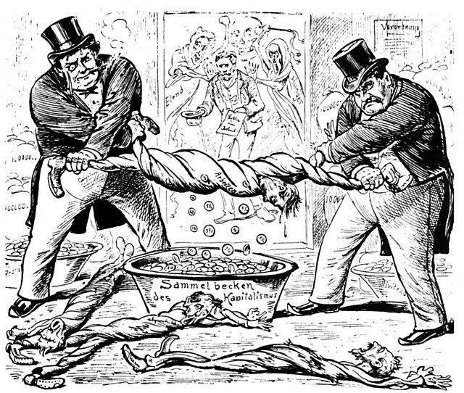

The new relationship between workers and entrepreneurs“, source: caricature from the ”Neue Postillon", Zurich, Switzerland 1896.

|  |
| --- |
| The first impression In order to analyze a caricature, it is first important to record the first impression. This will help the next steps of the analysis. |

### 📝Task

Make a note of your first impression. What is the first thing you notice? What feelings, thoughts or reactions does the caricature trigger?

___________________________________________________________________

___________________________________________________________________

___________________________________________________________________

___________________________________________________________________

### Determine whether the given statements are true or false.

###### **The cartoon was published in Zurich, Switzerland.**

True False

###### **The title of the cartoon is 'Das neue Verhältnis zwischen Arbeiter und Unternehmer'.**

True False

###### **The cartoonist's name is clearly mentioned in the description.**

True False

###### **The cartoon was published in the year 1906.**

True False

|  |
| --- |
| The formal analysis The analysis of a caricature follows several steps. Now use this profile for a formal analysis by first describing the caricature in detail. |

|  |  |
| --- | --- |
|  | Title |
| Author |
| Publication date |
| Source | |
| Theme | |
| Description- People and objects | |
| Description- Plot | |
| Description- Symbols and metaphors | |

|  |  |
| --- | --- |
|  | Title  Das neue Verhältnis zwischen Arbeiter und Unternehmer |
| Author  Unknown |
| Publication date  1896 |
| Source  Neuer Postillon, Zurich, Switzerland | |
| Theme  The cartoon critiques the exploitation of workers within the capitalist system. | |
| Description- People and objects  The cartoon features two capitalists in top hats wringing out a worker like a wet towel, while coins fall into a basin labeled 'Capitalism's collecting basin'. | |
| Description- Plot  The cartoon depicts the harsh treatment and exploitation of workers by capitalists, symbolizing the economic disparity and social injustices of the time. | |
| Description- Symbols and metaphors  The overflowing basin of coins represents the wealth accumulated by capitalists, while the limp posture of the workers symbolizes their exhaustion and hopelessness. | |

|  |
| --- |
| Interpretation & evaluation The final step of our analysis involves interpreting and evaluating the caricature. |

Explain how the cartoon uses imagery to depict the relationship between workers and capitalists.

___________________________________________________________________

___________________________________________________________________

___________________________________________________________________

Evaluate the effectiveness of the cartoon in conveying its critique of capitalism.

___________________________________________________________________

___________________________________________________________________

___________________________________________________________________