|  |
| --- |
| Background information Use the following text as background information on the topic of your picture description. Carefully read the text and mark or write down any relevant information. |

### Overview of Martin Luther King Jr.

Martin Luther King Jr. (MLK) was a Baptist minister and social activist who played a pivotal role in the American civil rights movement from the mid-1950s until his assassination in 1968. He is renowned for his advocacy of nonviolent resistance to racial discrimination and his significant impact on race relations in the United States. This overview aims to provide key information about Martin Luther King Jr., including his early life, major achievements, and lasting legacy, to help German students in the 10th grade prepare for their oral exams.

### Early Life

Born on January 15, 1929, in Atlanta, Georgia, Martin Luther King Jr. was originally named Michael King Jr. He came from a comfortable middle-class family deeply rooted in the tradition of the Southern Black ministry. His father, Martin Luther King Sr., was a Baptist preacher, and his maternal grandfather had also been a pastor. King's parents were both college-educated, and he grew up in a loving and supportive extended family.

Despite this secure upbringing, King experienced the harsh realities of racial segregation in the South from a young age. One significant incident occurred when he was around six years old, and a white playmate informed him that they could no longer play together because they were attending segregated schools. This early encounter with racial prejudice left a lasting impression on him.

In 1944, at the age of 15, King entered Morehouse College in Atlanta under a special wartime program that admitted promising high school students. Before starting college, he spent a summer working on a tobacco farm in Connecticut, where he was shocked by the relatively peaceful race relations compared to the segregated South. This experience deepened his growing hatred of racial segregation.

### Education and Influences

King initially considered studying medicine or law but decided to enter the ministry in his senior year at Morehouse College, influenced by the college president, Benjamin Mays, a social gospel activist. Mays' speeches and ideas about fighting racial inequality left a significant impact on King. He graduated from Morehouse in 1948 and went on to attend Crozer Theological Seminary in Pennsylvania, where he became acquainted with the philosophy of nonviolence espoused by Mohandas Gandhi.

King earned a bachelor of divinity degree from Crozer in 1951 and was elected president of the predominantly white student body, showcasing his exceptional oratorical skills and leadership qualities. He then pursued a doctorate at Boston University, where he studied theology and ethics, receiving his Ph.D. in 1955.

### Major Achievements

King's leadership in the civil rights movement began in earnest with the Montgomery Bus Boycott in 1955. The boycott was sparked by Rosa Parks' arrest for refusing to give up her bus seat to a white person. King's role in organizing the boycott brought him national prominence and marked the beginning of his commitment to nonviolent protest.

In 1957, King co-founded the Southern Christian Leadership Conference (SCLC), an organization dedicated to achieving civil rights through nonviolent means. He traveled extensively, giving speeches and organizing peaceful protests. One of his most famous actions was the March on Washington for Jobs and Freedom in 1963, where he delivered his iconic "I Have a Dream" speech. This speech, advocating for racial equality and an end to discrimination, remains one of the most powerful and enduring speeches in American history.

King's efforts were instrumental in the passage of the Civil Rights Act of 1964 and the Voting Rights Act of 1965, two landmark pieces of legislation that significantly advanced civil rights in the United States. In recognition of his tireless work, King was awarded the Nobel Peace Prize in 1964.

### Legacy

Martin Luther King Jr.'s legacy extends far beyond his lifetime. His advocacy for nonviolent resistance and his powerful rhetoric continue to inspire movements for social justice around the world. Tragically, King was assassinated on April 4, 1968, in Memphis, Tennessee, but his vision for a more just and equitable society lives on.

In the years following his death, King became a symbol of the American civil rights movement, and his contributions were commemorated with the establishment of Martin Luther King Jr. Day, a federal holiday observed on the third Monday of January each year. Monuments and memorials, such as the Martin Luther King Jr. Memorial in Washington, D.C., honor his life and work.

### Conclusion

Martin Luther King Jr. was a visionary leader whose commitment to nonviolent resistance and racial equality left an indelible mark on American society. His life's work helped dismantle institutionalized segregation and inspired future generations to continue the fight for civil rights. Understanding King's contributions and legacy is essential for students preparing for their oral exams, as it provides valuable insights into the history and ongoing struggle for social justice in the United States.

|  |
| --- |
| Guide to describing a picture Carefully read the following guide to describing a picture step-by-step. |

## Guide to Describing a Picture in English Class

Introduction:

When describing a picture in English, it is important to not only focus on what is visible, but also to bring in your background knowledge and relate it to the picture. This helps demonstrate your understanding of cultural, historical, and contextual elements which are an essential part of the exam.

Step-by-Step Guide:

1. Initial Observation:

Start with a General Overview:

Describe what you see in the picture in general. Mention the setting, the main subjects, and the overall impression.

Example: "The picture shows a busy city street during the day with many people walking and a few cars on the road."

2. Detailed Description:

Focus on Specific Elements:

Describe the main parts of the picture in more detail. This includes people, objects, and actions.

Example: "In the foreground, there is a woman pushing a stroller. To the left, a group of teenagers is gathered around a street performer who is playing the guitar."

3. Contextual and Background Knowledge:

Historical/Cultural Context:

Relate the picture to relevant historical or cultural knowledge. This is a critical part of the exam as it shows your understanding of the broader context.

Example: "This scene could be set in a Western city, possibly during the early 21st century, given the modern clothing and vehicles. The presence of a street performer is typical in many urban areas where public performances are part of the local culture and entertainment."

4. Interpretation:

Analyze the Picture:

Offer an interpretation of what is happening and why it might be significant. Use your background knowledge to support your interpretation.

Example: "The people seem to be in a hurry, which might indicate it is a weekday morning. This suggests that the city is in a country with a strong work ethic where people are heading to their jobs."

5. Personal Reaction and Reflection:

Express Your Own Views:

Share your personal reaction to the picture and reflect on the emotions or thoughts it evokes. This will show your ability to engage with the material on a deeper level.

Example: "This picture reminds me of my visit to Berlin, where the streets were always bustling with activity. It makes me think about the importance of public spaces in urban life and how they bring together people from different walks of life."

6. Connecting to Broader Themes:

Relate to Larger Issues:

Connect the picture to broader themes or issues such as social dynamics, environmental concerns, or technological advancements.

Example: "The image also raises questions about urbanization and its impact on the environment. The number of cars suggests a reliance on fossil fuels, which is a significant issue in modern cities dealing with pollution and climate change."

Practice and Preparation:

Practice Descriptions:

Regularly practice describing different pictures using this guide.

Expand Your Knowledge:

Read up on cultural, historical, and social contexts of English-speaking countries to enhance your background knowledge.

Seek Feedback:

Share your descriptions with teachers or peers to get feedback and improve.

By following these steps and emphasizing the importance of contextual and background knowledge, you will be well-prepared to describe pictures effectively in your English exams.

### Key Points to Remember:

Always start with a general overview.

Provide detailed descriptions of specific elements.

Incorporate historical and cultural context.

Offer interpretations based on your background knowledge.

Share your personal reactions and reflections.

Connect the picture to broader themes and issues.

Good luck with your studies and your exams!

|  |
| --- |
| Grammar present progressive  Remember that picture descriptions are done in . However, change the tense accordingly for talking about background information on the picture. |

|  |
| --- |
| Vocabulary Use the following list of vocabulary as a help for your picture description. |

### Vocabulary list for picture descriptions

positions:

in front of - vor

behind - hinter

next to - neben

between - zwischen

on the left - links

on the right - rechts

in the middle - in der Mitte

at the top - oben

at the bottom - unten

near - in der Nähe

far from - weit weg von

above - über

below - unter

in the background - im Hintergrund

in the foreground - im Vordergrund

others:

to describe - beschreiben

to show - zeigen

to indicate - anzeigen

to appear - erscheinen

to look like - aussehen wie

to seem - scheinen

to illustrate - veranschaulichen

to represent - darstellen

to point out - hinweisen auf

to focus on - sich konzentrieren auf

to capture - einfangen

|  |
| --- |
| Picture Now look at the following image in detail and take notes. You should write down anything that you notice about what's shown in the picture and what kind of background information will be important for your description. |

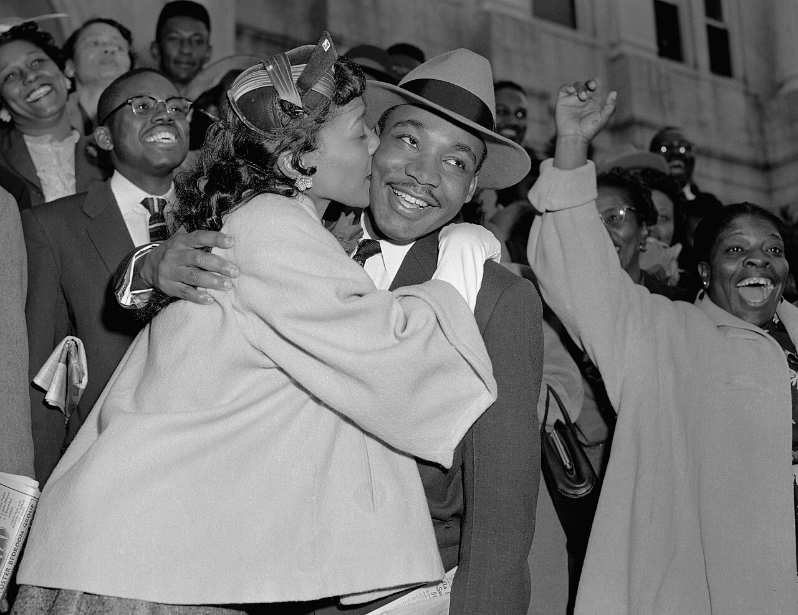

### Notes

Use this space to take notes.

___________________________________________________________________

___________________________________________________________________

___________________________________________________________________

___________________________________________________________________

|  |
| --- |
| Practising the picture description Use your notes as well as the vocabulary introduced in the worksheet and start practising your picture description. Try talking for about 5 minutes.    Once you're quite confident with your talk, present your picture description to your partner. They will fill out the feedback sheet below and give you feedback on what you did well and what you can still improve upon. |

|  |  |  |
| --- | --- | --- |
| Aspect | Yes/No | Ideas for Improvement |
| Introduction |  |  |
| Detailed picture description  Present progressive  Vocabulary |  |  |
| Context  Detailed background information  Interpretation |  |  |
| Conclusion |  |  |