Daniel

Hey Daniel! Guess what? I'm going to Serengeti National Park with my family soon!

No way, Lucy! That's awesome! What are you planning to see there?

So many things! We're definitely going to check out the Seronera Valley. It's known for its amazing wildlife.

That sounds cool. What else is on your list?

We're also planning to visit the Mara River. I heard the wildebeest migration there is incredible.

The migration must be an epic sight. Any other spots?

Yup! We're going to Ngorongoro Crater too. It's like a giant bowl filled with animals.

Wow, that sounds amazing. What about Grumeti River? I've read it's a great place to see crocodiles.

Yes! The Grumeti River is on our list too. And we're thinking of visiting the Lobo Valley to see some lions.

You have a packed itinerary! Are you excited about it?

Super excited! I can't wait to see all the animals and landscapes. What about you? Ever thought about visiting Serengeti?

Definitely! It's on my bucket list. I hope you take lots of pictures and tell me all about it when you get back.

For sure! I'll make sure to capture everything. Thanks, Daniel!

Have a great trip, Lucy! Can't wait to hear all about your adventure!

Thanks! Talk to you later!

List all the sights that Lucy and her family want to see in the national park.

___________________________________________________________________

___________________________________________________________________

___________________________________________________________________

### Serengeti National Park

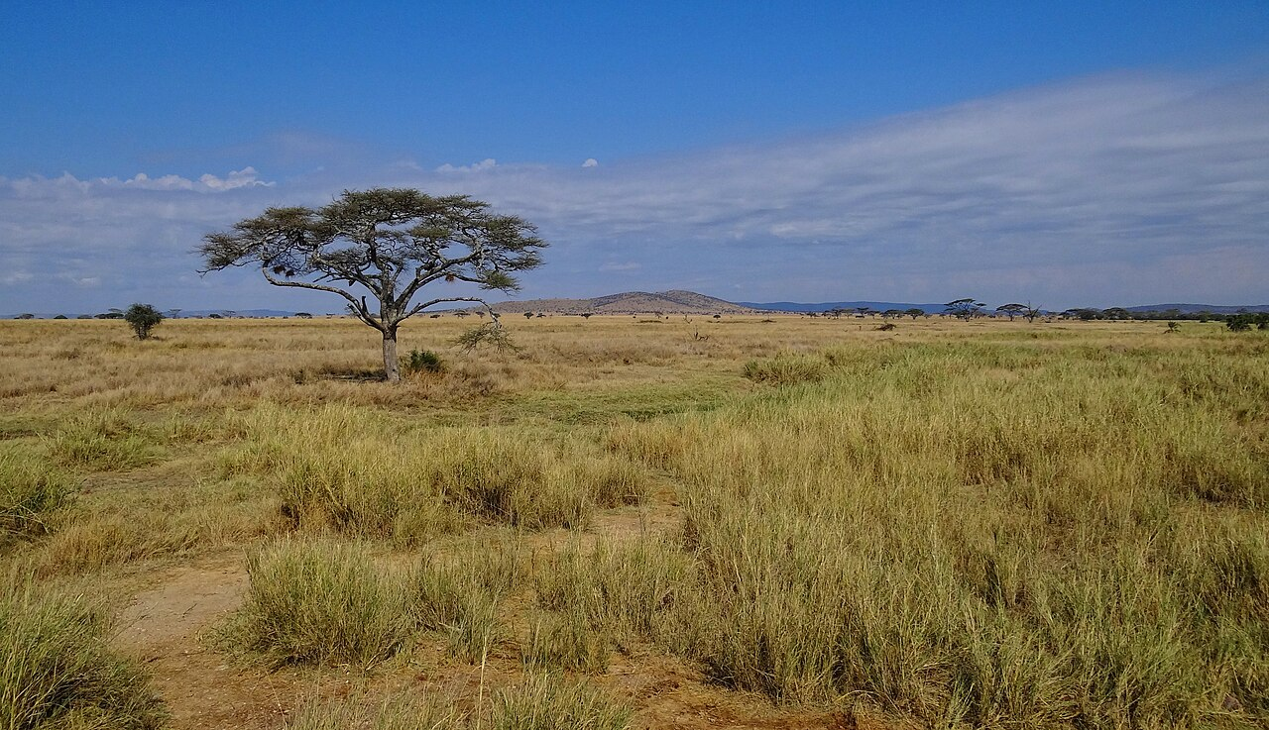

Bjørn Christian Tørrissen

CC BY-SA 3.0

Source: ,

Serengeti National Park is a famous wildlife reserve located in Tanzania, East Africa. It covers an area of about 14,750 square kilometers, making it one of the largest national parks in the world. The park is known for its stunning landscapes, which include vast grasslands, savannas, and rivers.

One of the most amazing things about the Serengeti is the Great Migration, where over a million wildebeest, zebras, and gazelles move across the plains in search of fresh grass. This event happens every year and is a spectacular sight to see. The Serengeti is also home to the "Big Five" animals: lions, elephants, buffalo, leopards, and rhinos.

The climate in the Serengeti is generally warm and dry, with a rainy season from March to May and a shorter rainy season in November and December. This climate supports a rich variety of plants and animals. Important places within the park include the Seronera Valley, known for its high density of big cats, and the Grumeti River, where you can see crocodiles and hippos.

Tourism is a big part of the Serengeti, with many visitors coming to see the wildlife and natural beauty. Safari tours are very popular, and there are many lodges and campsites where tourists can stay. However, there are some dangers, such as wild animals and diseases like malaria, so it's important to be careful and follow guidelines.

A special feature of the Serengeti is its role in research and conservation. Scientists study the animals and plants to learn more about how to protect them. The park is also a UNESCO World Heritage site, which helps ensure its preservation for future generations.

In summary, Serengeti National Park is a unique and important place filled with incredible wildlife, beautiful landscapes, and a rich natural history.

### Read the text about the national park. Then fill in the blanks with the correct information.

Serengeti National Park is a renowned ________________ reserve located in Tanzania, East Africa. The park spans approximately 14,750 square kilometers, making it one of the ________________ national parks globally. It is celebrated for its picturesque landscapes, including vast grasslands, ________________, and rivers. One of its most remarkable features is the Great Migration, where over a million wildebeest, zebras, and gazelles traverse the plains in search of fresh grass. Serengeti is also home to the "Big Five" ________________: lions, elephants, buffalo, leopards, and rhinos. The climate is generally warm and dry, with a ________________ season from March to May and a shorter rainy season in November and December. Tourism plays a significant role in the park, with many visitors coming to experience its ________________ beauty and wildlife. Additionally, the Serengeti is a UNESCO World Heritage site, contributing to its conservation and ________________ efforts.

Imagine Lucy and her parents meet a park ranger in the national park. Use the information from the text and think of some questions they could ask him, then write a conversation between the four persons.

___________________________________________________________________

___________________________________________________________________

___________________________________________________________________