# Dwarf planet

|  |
| --- |
| Prior knowledge What do you already know about the topic? Collect your knowledge together as a class and create a mindmap. |



# Dwarf Planet

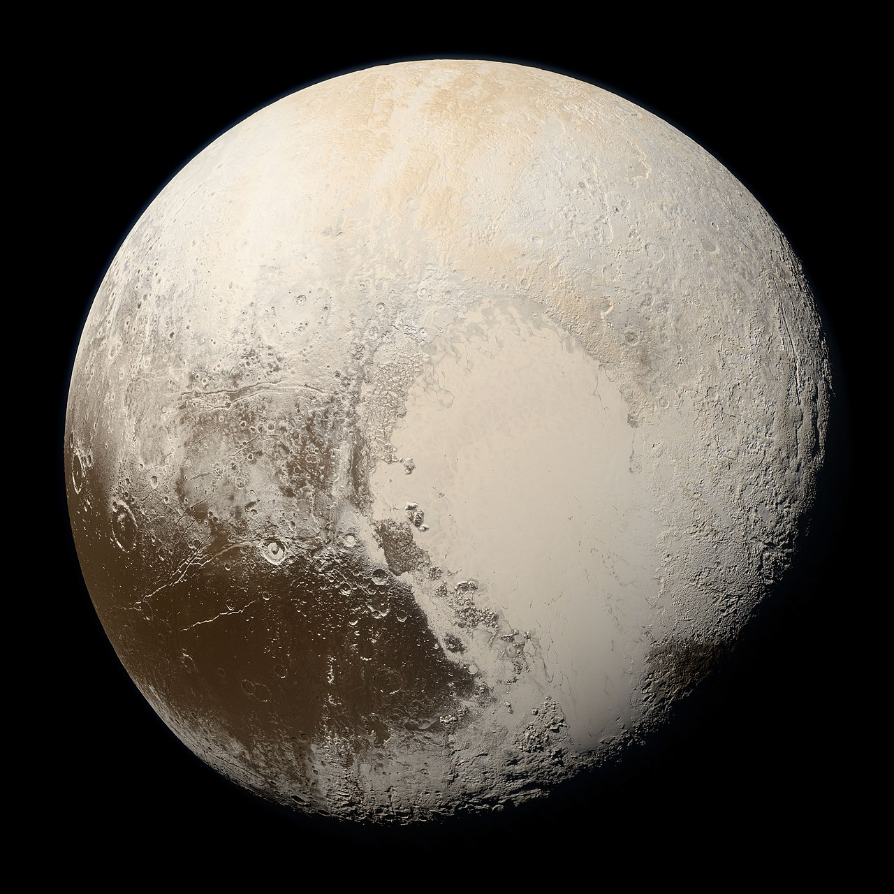

Wikipedia

Source:

A dwarf planet is a type of celestial body that orbits the Sun, similar to a planet but with some differences. Unlike the eight main planets, a dwarf planet does not clear its orbit of other debris. This means it shares its orbital path with other objects, like asteroids and comets.

One of the most well-known dwarf planets is Pluto. For a long time, Pluto was considered the ninth planet in our solar system. However, in 2006, the International Astronomical Union (IAU) redefined what it means to be a planet, and Pluto was reclassified as a dwarf planet. Other examples of dwarf planets include Eris, Haumea, Makemake, and Ceres.

Dwarf planets are interesting because they share characteristics with both planets and smaller solar system bodies. They are large enough to be rounded by their own gravity but not large enough to clear their orbital path. This makes them an exciting subject of study for astronomers.

Ceres, the closest dwarf planet to Earth, is located in the asteroid belt between Mars and Jupiter. It was the first dwarf planet to be visited by a spacecraft, NASA's Dawn mission, which provided detailed images and data about its surface and composition.

Understanding dwarf planets helps scientists learn more about the formation and evolution of our solar system. These bodies can provide clues about the processes that shaped the planets and other objects we see today. For example, studying the surface features of dwarf planets like Pluto and Ceres can reveal information about their geological history and the presence of water ice.

In summary, dwarf planets are fascinating objects that bridge the gap between planets and smaller celestial bodies. They offer valuable insights into the history and dynamics of our solar system, making them an essential topic in astronomy.

### For each statement, choose if it's true or false.

###### **A dwarf planet is a type of celestial body that orbits the Sun.**

True False

###### **Pluto is still considered the ninth planet in our solar system.**

True False

###### **Dwarf planets do not clear their orbit of other debris.**

True False

###### **Ceres is located in the asteroid belt between Mars and Jupiter.**

True False

###### **The International Astronomical Union reclassified Pluto as a dwarf planet in 2016.**

True False

###### **Dwarf planets are not large enough to be rounded by their own gravity.**

True False

###### **The Dawn mission was the first spacecraft to visit a dwarf planet.**

True False

###### **Eris, Haumea, and Makemake are examples of dwarf planets.**

True False

|  |
| --- |
| The interview Read an interview with a physicist who is talking about the current state of research. Then answer the questions. |

Interviewer:

Hi, everyone! Today, we have a special guest with us. This is Dr. Rachel Green, a physicist who knows a lot about dwarf planets. Welcome, Dr. Green!

Dr. Rachel Green:

Hello! Thank you for having me. I'm excited to talk about dwarf planets with you all.

Interviewer:

Can you tell us why you know so much about dwarf planets?

Dr. Rachel Green:

Sure! I've been studying dwarf planets for 15 years. I work at a space research center, and I use telescopes and other tools to learn about these fascinating objects in our solar system.

Interviewer:

When did scientists start studying dwarf planets?

Dr. Rachel Green:

Scientists have been interested in dwarf planets for a long time, but it wasn't until 2006 that we officially started calling them "dwarf planets." Before that, we just called them small planets or large asteroids.

Interviewer:

What is the current state of research on dwarf planets?

Dr. Rachel Green:

Right now, we know a lot more about dwarf planets than ever before. We have sent spacecraft like New Horizons to visit Pluto, which is one of the most famous dwarf planets. This mission has given us amazing pictures and data.

Interviewer:

What important questions have already been answered about dwarf planets?

Dr. Rachel Green:

We have learned that dwarf planets are like small versions of regular planets. They have moons, and some even have atmospheres. We also know that they are found mostly in two areas of our solar system: the Kuiper Belt and the asteroid belt.

Interviewer:

What important questions are still not answered?

Dr. Rachel Green:

There are still many things we don't know. For example, we want to understand more about how dwarf planets formed. We also want to know if there are more dwarf planets we haven't discovered yet. Plus, we are curious about what their surfaces and interiors are like.

Interviewer:

That sounds really interesting! Thank you for sharing all this with us, Dr. Green.

Dr. Rachel Green:

You're welcome! I hope you all enjoyed learning about dwarf planets. Keep looking up at the stars and wondering about the universe!

Interviewer:

Thanks again, Dr. Green. Bye, everyone!

Why did scientists start calling some planets 'dwarf planets' and when did this happen?

___________________________________________________________________

___________________________________________________________________

___________________________________________________________________

What have scientists learned about dwarf planets so far, and what are some questions they still have?

___________________________________________________________________

___________________________________________________________________

___________________________________________________________________