|  |
| --- |
| Introduction This worksheet is about exchange rates. You will take a detailed look at the exchange rate between two different currencies. |

Imagine you have just arrived from Germany and landed in Japan for your vacation. At the airport, you decide to exchange your money, but the exchange rate is different from what you expected, and you receive fewer yen for your euros. Later, while sitting in a cozy café, you overhear some people discussing how the exchange rate often fluctuates. You start to wonder why this happens. Why can't the exchange rate remain constant all the time?

### 📝 Task

Think about what could lead to fluctuating exchange rates. Write down your thoughts.

___________________________________________________________________

___________________________________________________________________

___________________________________________________________________

___________________________________________________________________



# Causes of exchange rate changes

Exchange rates are the prices at which currencies are exchanged. They constantly change due to various factors. One primary reason for exchange rate changes is supply and demand for currencies. If many people want to buy a particular currency, its value increases. Conversely, if fewer people want a currency, its value decreases.

Interest rate differences between countries also play a significant role. When a country has higher interest rates compared to others, investors prefer to invest their money there to get better returns. This increases the demand for that country's currency, causing its value to rise.

Inflation, which means the rise in prices of goods and services, affects exchange rates too. If a country has high inflation, its currency loses value compared to others. People would rather hold currencies from countries with lower inflation since their money retains value better.

Economic and political stability is another crucial factor. Countries with stable economies and politics attract more investments, increasing the demand for their currency and boosting its value. On the other hand, political unrest or economic problems decrease confidence in a currency, leading to a drop in its value.

The trade balance, which is the difference between a country's exports and imports, impacts exchange rates as well. If a country exports more than it imports, the demand for its currency rises, increasing its value. Conversely, if a country imports more than it exports, its currency value drops.

Speculation, where traders buy and sell currencies hoping to profit from changes in exchange rates, can also cause fluctuations. If many traders believe a currency will rise in value, they buy it, causing its value to increase. If they think it will drop, they sell it, leading to a decrease in value.

Currently, the exchange rate between the euro and yen is experiencing significant fluctuations. One reason is the different economic situations in Europe and Japan. Europe is facing various economic challenges, while Japan's economy is relatively stable. Moreover, the interest rate differences between the European Central Bank and the Bank of Japan are influential. The Bank of Japan maintains very low interest rates, while the European Central Bank is raising rates to combat inflation. This makes the yen more attractive.

In summary, exchange rates are influenced by supply and demand, interest rate differences, inflation, economic and political stability, trade balance, and speculation. These factors often act together, causing exchange rates to change quickly and unpredictably.

### 📝 Add the causes of exchange rate fluctuations from the previous task.

Note field

___________________________________________________________________

___________________________________________________________________

___________________________________________________________________

___________________________________________________________________

📝 Summarize what influences the exchange rate conditions of both countries.

___________________________________________________________________

___________________________________________________________________

___________________________________________________________________

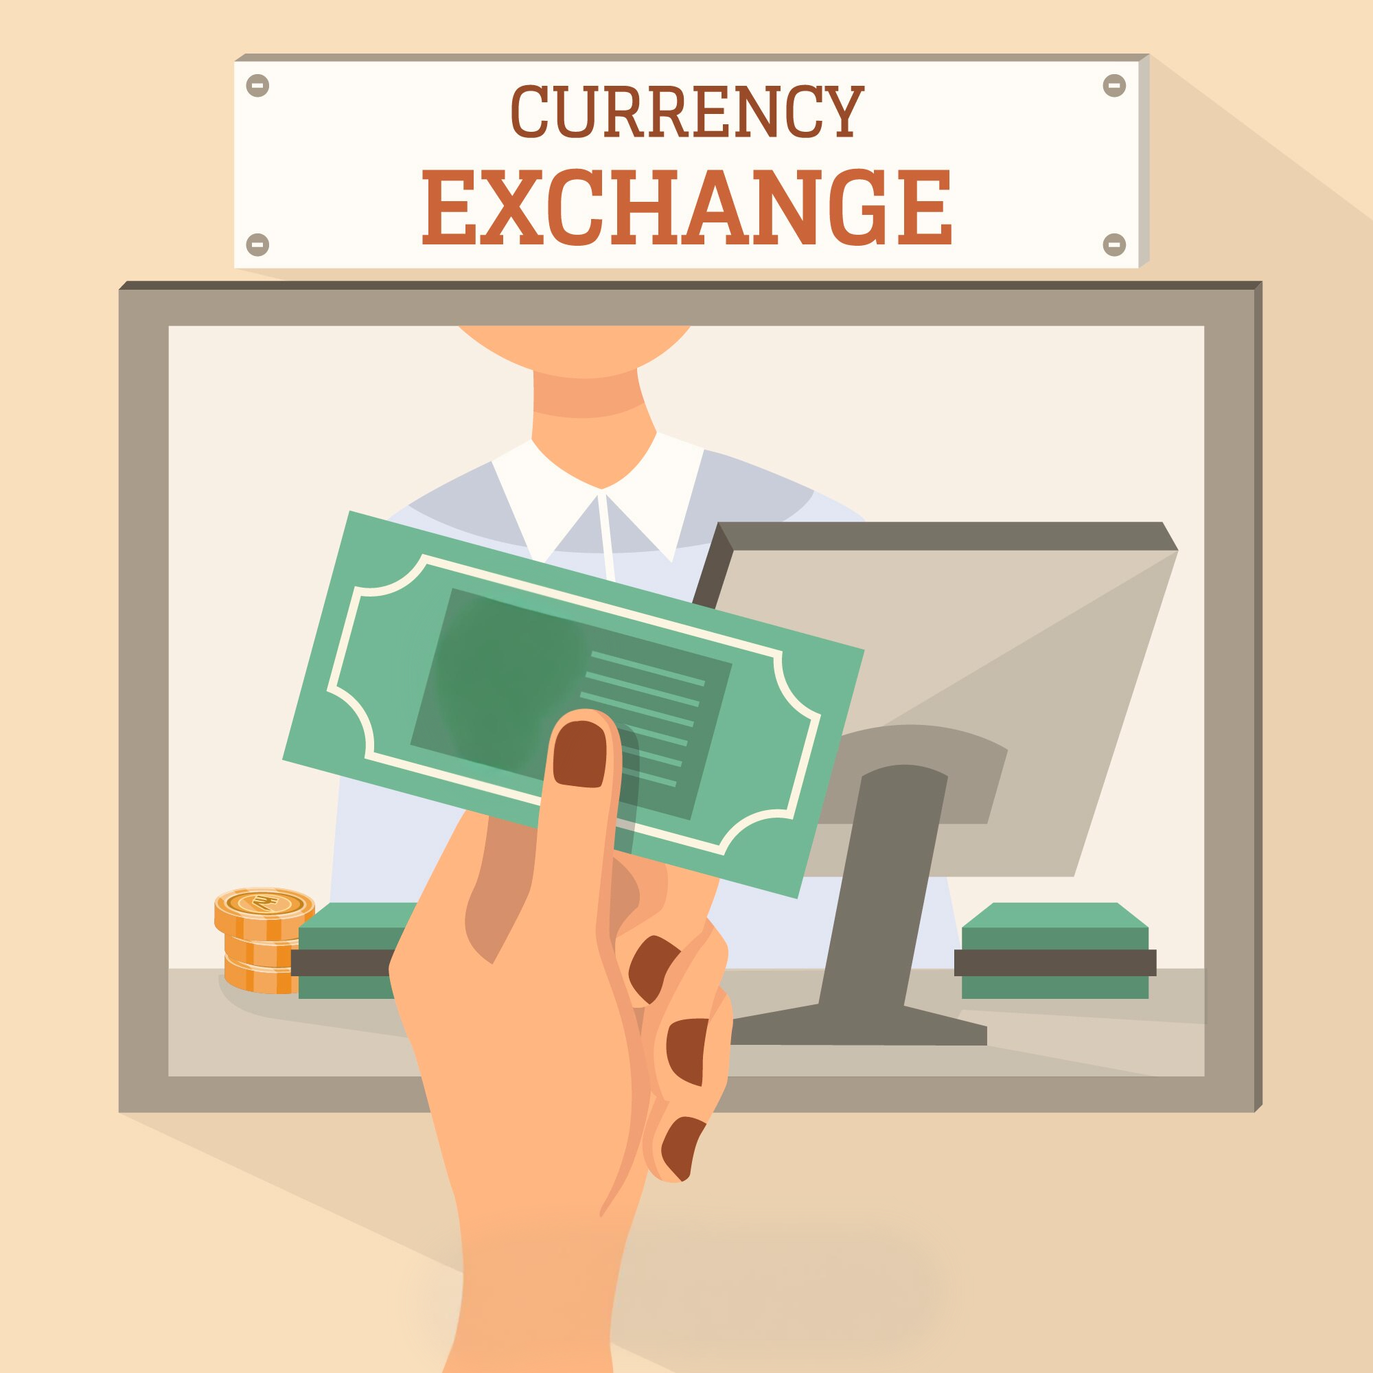

|  |  |
| --- | --- |
|  | Entrepreneur  As an entrepreneur, the exchange rate is crucial for my business. The strong Yen compared to the Euro means that our exports to Japan become more expensive. This can lead to a decrease in demand for our products and reduce our profits. However, imports from Japan are cheaper now, which is beneficial if we need Japanese raw materials or machinery. Due to the strong Yen, we are considering expanding our business in Japan, as we can make more cost-effective investments there. However, we need to be cautious, as changes in the exchange rate can directly impact our profit margins.  Exchange rates influence the profits and investment decisions of businesses. |
|  | Consumer  As a consumer in Japan, I feel the impact of the strong Yen in my daily life. Imported goods from Europe are now more expensive, which means I have to pay more for certain foods and products. This strains my budget. On the other hand, local products and services have remained stable, providing some balance. Overall, I feel that my life has become more expensive because I buy many imported products.  Exchange rates affect the cost of daily life for consumers. |
|  | Tourist  As a tourist from Europe visiting Japan, I can clearly see the effects of the exchange rate. The strong Yen means I get fewer Yen for my Euros, making my trip more expensive. This affects the cost of my hotel, meals, and souvenirs. The exchange rate also impacts how much I get for my European money when I change it into Yen. Overall, I have to plan my budget carefully and may need to skip some activities to keep my costs manageable.  Exchange rates impact travel costs and budget planning for tourists. |

📝 Summarize the impact of exchange rate conditions on businesses, consumers and travelers.

___________________________________________________________________

___________________________________________________________________

___________________________________________________________________

