|  |
| --- |
| Introduction In this worksheet, you will look at a well-known artist. You will find out what themes and techniques they used and how their works influenced the art world and society. The aim is to reflect on and understand the significance of their work. |

# Marina Abramović: The Empress of Endurance

Marina Abramović, born on November 30, 1946, in Belgrade, Yugoslavia, is a groundbreaking performance artist whose work has redefined the limits of physical and mental endurance. Often referred to as the "grandmother of performance art," Abramović has been a pivotal figure in the art world since the early 1970s, creating works that challenge both herself and her audience in profound ways.

Abramović's journey into art began at the Academy of Fine Arts in Belgrade, where she initially studied painting. However, she soon discovered that traditional mediums could not fully express her ideas, leading her to embrace performance art. Her early works, such as "Rhythm 0" (1974), where she offered herself as an object to the audience with 72 items—including a loaded gun—demonstrated her fearless approach to exploring human nature and vulnerability.

One of Abramović's most iconic performances, "The Artist Is Present" (2010), took place at the Museum of Modern Art in New York. For 736 hours, she sat silently in a chair, inviting visitors to sit across from her and share a moment of connection. This piece not only showcased her extraordinary endurance but also highlighted the profound impact of human presence and interaction.

Abramović's work often reflects her personal history and the turbulent political landscape of Yugoslavia. Her performance "Balkan Baroque" (1997), where she cleaned a pile of bloody cow bones for six days, won the Golden Lion at the Venice Biennale and was a poignant commentary on the violence and suffering in her homeland.

In addition to her physical performances, Abramović has embraced digital art and has even founded the Marina Abramović Institute, dedicated to the preservation and study of performance art. Interestingly, Abramović has stated that she plans to continue creating art beyond her death, with holograms of herself performing.

A lesser-known fact about Abramović is her collaboration with pop culture icons. In 2013, she worked with Jay-Z on his music video "Picasso Baby," blending high art with mainstream music. This collaboration is a testament to her versatility and ability to transcend traditional art boundaries.

Marina Abramović's work is both mesmerizing and provocative, pushing the boundaries of what art can be and challenging audiences to confront their own limits and fears. Her contributions to performance art have left an indelible mark, making her an enduring icon in the contemporary art world. The paradox of her work lies in its ability to be both intensely personal and universally resonant, inviting viewers to explore the depths of human experience and endurance.

### 📝 Place the text about the artist in a remote place in the classroom. Now read the text and go back to your seat to write down one piece of information that you found most important or interesting. Repeat the process 2-3 times.

___________________________________________________________________

___________________________________________________________________

___________________________________________________________________

___________________________________________________________________

👥 Discuss the information you have selected with a partner and add to your notes if necessary.

## The Artist Is Present

Marina Abramović's most iconic performance, "The Artist Is Present" (2010), took place at the Museum of Modern Art in New York. This groundbreaking work involved Abramović sitting silently in a chair for 736 hours over the course of three months, inviting visitors to sit across from her and share a moment of connection. The simplicity of the setup belied the profound emotional and psychological depths that the performance reached. Participants often experienced intense emotional responses, some even breaking into tears, moved by the raw human presence and vulnerability Abramović offered.

"The Artist Is Present" is significant in the art world for several reasons. Firstly, it showcased Abramović's extraordinary endurance, both physically and mentally, as she maintained her presence without speaking or moving for such a prolonged period. This endurance is a hallmark of her work, but this piece took it to an unprecedented level. Secondly, the performance highlighted the power of human interaction and the impact of presence. In an age of digital communication and fleeting connections, Abramović's work reminded audiences of the profound nature of face-to-face encounters.

The performance also challenged traditional notions of what art can be. By stripping away any elaborate setup or narrative, Abramović focused on the raw, unmediated experience between herself and the audience, making the interaction itself the art. This minimalist approach has influenced countless artists and has cemented "The Artist Is Present" as a pivotal moment in contemporary art history. The work resonates universally, inviting viewers to confront their own vulnerabilities and the essence of human connection, making it an enduring and transformative piece.

📝 Research the work 'The Artist Is Present' by Marina Abramović and describe it briefly.

___________________________________________________________________

___________________________________________________________________

___________________________________________________________________

# Influences on development

|  |  |
| --- | --- |
|  | Marina Abramović  Growing up in Belgrade, Yugoslavia, my early life was deeply influenced by the political landscape of post-war Yugoslavia. Both of my parents were Yugoslav Partisans, and their involvement in the government exposed me to complex socio-political environments. This background shaped my work, particularly in pieces like 'Balkan Baroque,' where I address violence and suffering through intense acts. Initially, I studied painting at the Academy of Fine Arts in Belgrade and Zagreb, but soon found traditional mediums inadequate. Influenced by performance art movements like Viennese Actionism and Fluxus, I began using my body as my primary medium. Collaborations with Ulay, a fellow artist, were crucial in my artistic evolution. We explored dynamics between male and female principles, trust, and artistic identity. These experiences, combined with my interactions with contemporary pop culture, have solidified my position as a pivotal figure in performance art. |

📝 Read the artist's statement. Summarize which influences have affected the person's artistic work.

___________________________________________________________________

___________________________________________________________________

___________________________________________________________________

📝 Explain a selected influence on the artist's artistic work in detail. Research additional information online.

___________________________________________________________________

___________________________________________________________________

___________________________________________________________________

## Marina Abramović: Enduring Influence in Contemporary Art

Marina Abramović's impact on the art world is undeniable, with her groundbreaking performances continuing to inspire and provoke audiences worldwide. Her fearless exploration of physical and emotional boundaries has influenced a generation of artists, pushing the limits of what art can communicate.

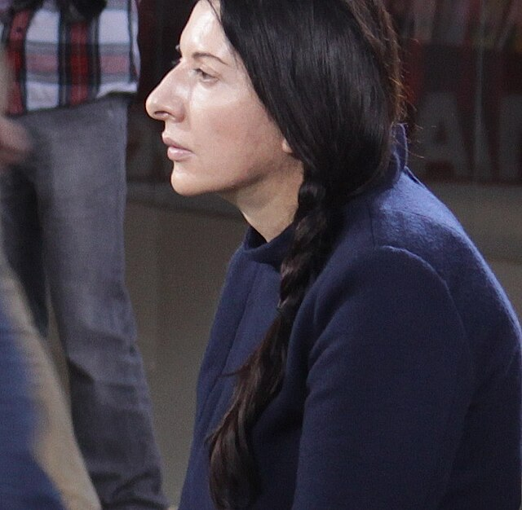

Marina Abramović at work, Museum of Modern Art, 2010. Source: Wikimedia Commons CC BY-SA 3.0

Abramović's work, particularly "The Artist Is Present," has left a lasting legacy by redefining the concept of endurance in art. This performance not only showcased her extraordinary stamina but also highlighted the profound impact of human presence and interaction. The emotional responses from participants underscored the universal need for connection and empathy.

Her innovative approach has paved the way for contemporary artists to explore the depths of human experience. Abramović's influence extends beyond the art world; her collaborations with pop culture icons like Jay-Z demonstrate her versatility and ability to transcend traditional boundaries. By embracing digital art and founding the Marina Abramović Institute, she continues to shape the future of performance art.

Marina Abramović's work remains relevant today, challenging audiences to confront their own limits and fears. Her contributions to performance art have left an indelible mark, making her an enduring icon in contemporary art. As new generations of artists draw inspiration from her work, Abramović's legacy will undoubtedly continue to resonate within the art community and beyond.

📝 Explain the significance of the artist for art history.

___________________________________________________________________

___________________________________________________________________

___________________________________________________________________

